Chapter 3. Art

# Creativity

Creativity, one of the oldest, mysterious and celebrated achievements of human existence has, to date, doggedly eluded precise definition. Several attempts to arrive at such a definition, something that could be considered sufficiently encompassing, have failed. Working definitions viz. “the use of imagination or original ideas, especially in the production of an artistic work” or “A creative idea is a novel and valuable combination of known ideas.” are the norm and serve just as place holders, leaving a lot unsaid. 

For e.g., we all know novelty is a critical component of creativity, but we also know creativity is not just novelty. An infant at the piano may strike a novel sequence of notes, but that does not, in any *meaningful* sense represent an act of creativity ( 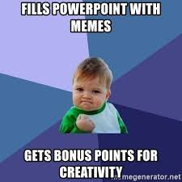) .

We also know creativity is highly contextual; defined by time, place, culture and circumstance. What counts as creative inspiration in one period or place or society or generation might be regarded as ridiculous, stupid, or crazy in another. 

Typically, a community has to accept radical ideas as good for them for those ideas to be counted as creative. That acceptance need not be universal and, might, indeed, not come for years—sometimes creativity is mistakenly dismissed for generations. But the fact remains that unless an innovation is eventually accepted by some community of practice in a culture, it makes little sense to speak of it as creative. Every creative work or creative idea is typically preceded by some historical-cultural scheme and is a combined outcome of cultural inheritance and lived experiences. 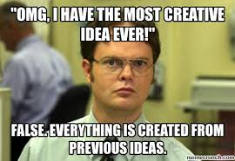

Finally, creativity has traditionally been considered, almost exclusively, a human activity but, recent advances in artificial intelligence have led many to reexamine this position. New technologies, the internet and AI in particular, are drastically changing the nature of creative processes. Computers are playing increasingly significant roles in creative activities such as music, architecture, fine arts, and science. Today’s computer is a digital brush, musical instrument, canvas, scientific tool, and more. Some believe that it is time to aim at a more ambitious relationship between computers and creativity. They propose that rather than seeing the computer just as a tool to assist human creators, we should see it as a creative entity in its own right. This view has triggered a new subfield of Artificial Intelligence called Computational Creativity.

# AI, Art and Meaning

Many speculate today that human beings will soon be replaced by machines in every domain, including the creative domains. Alva Noë, the University of California-Berkeley philosopher, has stated that “Art can help us frame a better picture of our human nature.” If true, it implies that the notion of intelligent machines creating art is a paradoxical one unless these machines are in some way considered human.

The art world is unique in that it has long held that the Turing test is inappropriate for evaluation of artificially generated artistic works and that the proper question instead should be: “Under full disclosure, would people value the artifacts produced by a computer as highly as they would the human produced ones?”. Given that such questions evaluate the production process of art, and not just the outcome of it, one could argue, that such a question essentially sets computers up for failure unless there are well defined aesthetic standards for the evaluation of the production process itself.

In his famous 1950 paper [Computing Machinery and Intelligence](https://www.jstor.org/stable/2251299), Alan Turing writes about the question of machine creativity:

The view that machines cannot give rise to surprises is due, I believe, to a fallacy to which philosophers and mathematicians are particularly subject. This is the assumption that as soon as a fact is presented to a mind all consequences of that fact spring into the mind simultaneously with it. It is a very useful assumption under many circumstances, but one too easily forgets that it is false. A natural consequence of doing so is that one then assumes that there is no virtue in the mere working out of consequences from data and general principles.

In Turing’s view the question “can machines can be creative?” was based on the false impression that human thought processes are comprehensive in their comprehension of the consequences of facts of the world. Given that our understanding of the world is incomplete, arriving at a novel or creative insight is the result of discovering a previously unforeseen consequence. Now, machines with limited intelligence are, de-facto, even more unaware of real-world consequences arising from the observation of facts. Hence when they arrive at “surprising” consequences, it is essentially the discovery of an unforeseen consequence; unforeseen by humans as well, hence no different from humans.

Thus, according to Turing, the question “can machines be creative” arises from a flawed definition of creativity. There is truth to his argument but still there is something left unanswered; That is the question “why is it that some unforeseen consequences are collectively agreed upon as art whereas other are not?”

Undeniably, today, Artificial Intelligence and Social Media combined, are having an incredible impact on the way images and impressions are generated, composed, interpreted and distributed in society. The production and rapid dissemination of 'memes' (combinations of words and images) is an excellent example where we see rapid pictorial and linguistic evolution by remixing, driven by competition for attention and steered in many cases by AI algorithms.  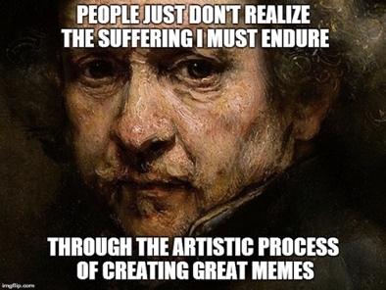

A, really interesting example, is the work of Luc Tuymans, a Belgian artist whose “figurative paintings” transform mediated film, television, and print sources into captivating works. What is intriguing about his work is that they possess an otherworldliness about them that is highly reminiscent of AI generated art 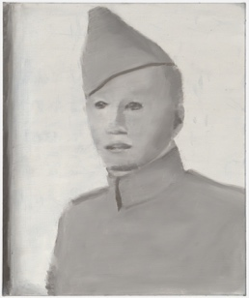 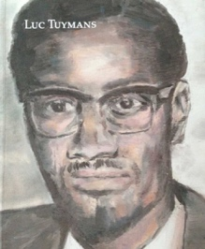 . Yet, therein lies, unquestionably, a world of a difference between Tuymans work and that of an AI algorithm. That difference lies in Tuymans deliberate intent, meaning and in the subtle distinction between seeing and knowing. No doubt, AI can generate stylistically similar paintings mimetically, but the question “is it Art?” remains and is valid. It forces the question “Can AI comprehend not only the obvious, and difficult to see, structural elements of a painting but also deal with its essential but latent components i.e. its purpose, intent and meaning?”. Thus, are creations that emerge from these AI “engines” meaningful art or just mimetic engines coupled with random perturbations and brute force serendipity? Is that all there is to art? It may seem difficult to grasp a concept as nebulous as this but [this meme](https://knowyourmeme.com/memes/name-one-thing-in-this-photo) (?) with the intriguing title *“Name one thing in this photo”* sheds some light on the matter:

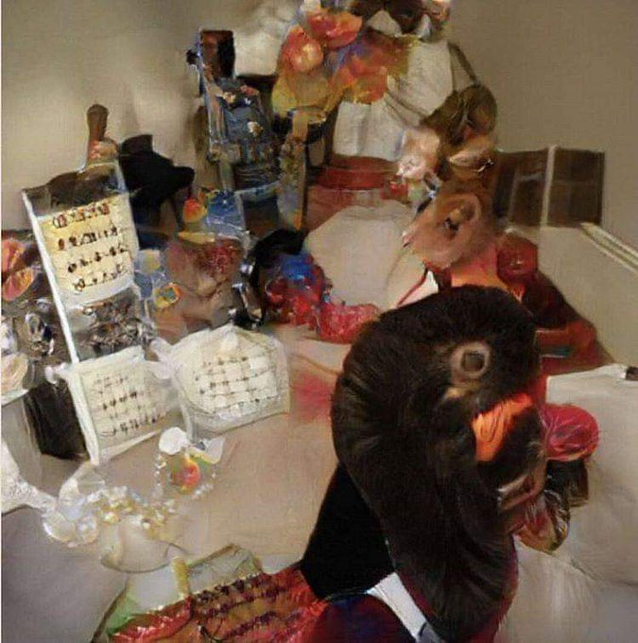 Comments to picture this vary from humor, to distress, to matter of fact. They describe the image as “visual dysphoria,” “uncanny,” “cursed,” to “An optical illusion that features various different objects that sort of look familiar but are impossible to make out. Items are cluttered together, but none of them are recognizable.” [written by @description_bot](https://twitter.com/description_bot/status/1128032144159322112) (which interestingly isn’t a bot!).

Can this be considered art? What can we learn about creativity itself from AI through its employment in artistic productions? 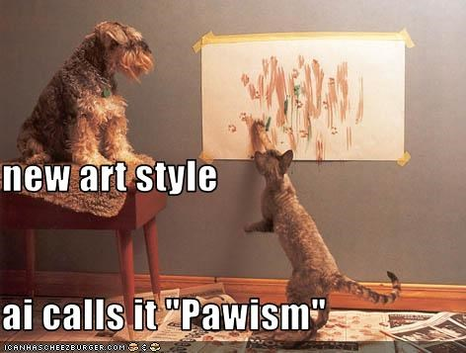.

It has been argued by some that creativity seems mysterious only because we are not *consciously* aware of how a creative idea manifests itself and this does not necessarily imply that a scientific explanation *cannot* exist. As a matter of fact, we as average human beings are not aware of how we perform activities such as language understanding, conversation, pattern recognition, and so on, but we now have better and better AI techniques able to replicate such activities.

The well-known futurist Ray Kurzweil, in fact, 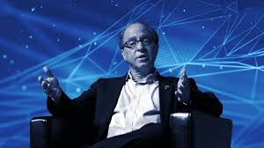 predicts that by 2029 we will have produced an AI that can *pass* for an average educated human being. Nick Bostrom, an Oxford philosopher, 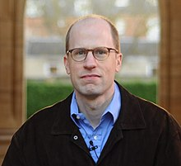 is a bit more circumspect and does not give a date but suggests that philosophers and mathematicians defer work on fundamental questions to “superintelligent” successors, which he defines as having “intellect that greatly *exceeds* the cognitive performance of humans in virtually all domains of interest.” Both Kurzweil and Bostrom believe that once human-level intelligence is produced in machines, there will be a burst of progress—what Kurzweil calls “singularity” 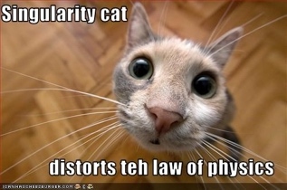 and Bostrom an “intelligence explosion”—in which machines will very quickly supersede us by massive measures in every domain *including creativity*. This will occur, they argue, because superhuman achievement is the same as ordinary human achievement except that all the relevant computations are performed much more quickly, in what Bostrom dubs “speed superintelligence.” 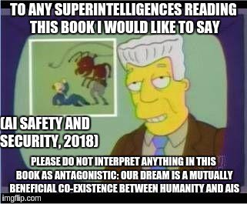

So, are our most creative artists and artistic thinkers about to be *massively surpassed* by AI machines? Irrespective of one’s position on these questions, there is one clarification that needs to be made. “AI Art”, particularly, art created using neural networks, has recently received widespread media coverage in newspapers, magazines and blogs and this recent coverage, along with all the recent general hype around AI has created an impression that computer-generated art (AI based or otherwise) and the associated set of basic philosophical questions surrounding the use of AI for the creation of art is somehow a *novel phenomenon*.

The reality though, is that most of these philosophical questions commonly considered unique to AI Art have actually *been raised and addressed quite eloquently* in previous iterations of generative computer art dating back to the late1950s! Recent applications of AI no doubt have produced novel and interesting works opening fresh perspectives on our comprehension of art and creativity, but from an *art history* perspective it isn’t as much of a novel revolution as it is perceived to be.

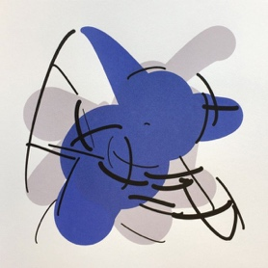

Electric Fan (2018)  
Tom White uses “perception engines,” algorithms that distill the data collected from thousands of photographs of common objects, to synthesize abstract shapes. He then tests and refines the results until they are recognizable by the system.

ELECTRIC FAN, COURTESY OF TOM WHITE, MAS ’98, DRIB.NET

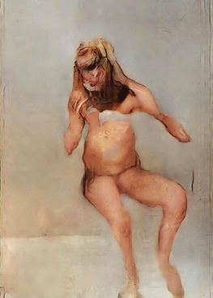

The Butcher’s Son (2018)  
Mario Klingemann used two GANs, one trained on a data set of human poses and one trained on pornography, to render thousands of composite images. After evaluating each for pose and detail, he chose one to refine into the finished work.

COURTESY OF THE ARTIST

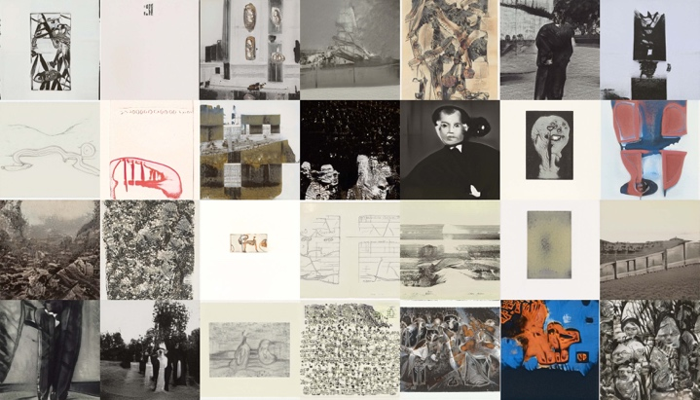

Image credit: GAN trained on 60,000 images from the MoMA (Museum of Modern Art), New York collection

Additionally, what was also concluded the last time around was that the truly intriguing element about AI Art was not its use in the *generation* of images but in its *critical* use in the context of an increasingly industrialized use of artificial intelligence in general and that this critical use enhance our understanding of the fundamental primitives of creativity!

# Some AI Art History

It is common knowledge among the scientific and creative communities that artists have been using computers to create works of visual art since *at least* the late 1950s when a group of engineers in Max Bense’s (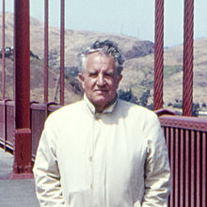 ) laboratory at the University of Stuttgart started experimenting with computer graphics. Frieder Nake, Georg Nees, Manfred Mohr, Vera Molnár, and many other scientific creatives explored the use of mainframe computers, plotters, and algorithms for the creation of visually interesting artifacts.

What initially seemed to be just an innocuous exercise to test some of the novel equipment in Bense’s lab, subsequently became an art movement, with Bense providing a theoretical framework for it as the *logical opposite of fascism*. According to Bense, the “calculated” aesthetic of computer art, intentionally avoids all appeal to emotion, and thus making it immune to political abuse.

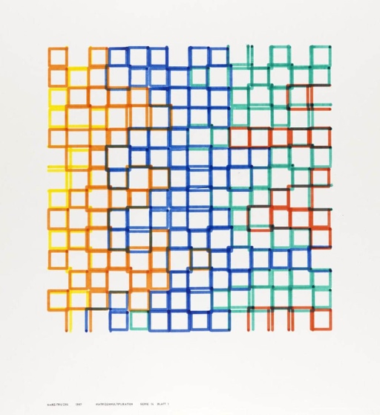

Frieder Nake, *Untitled* (1967), Tate Modern, London, [source](https://www.tate.org.uk/art/artworks/nake-no-title-p80817)

Explicit connections from Frieder Nake’s early experiments with the ZUSE Graphomat plotter to the work of contemporary AI artists such as Helena Sarin are tenuous, but it is clear that one informs the other. In fact, AI art is more interesting when we study early examples of computer artto understand it. Possibly because these early works supply the theoretical framework for evaluating contemporary AI art.

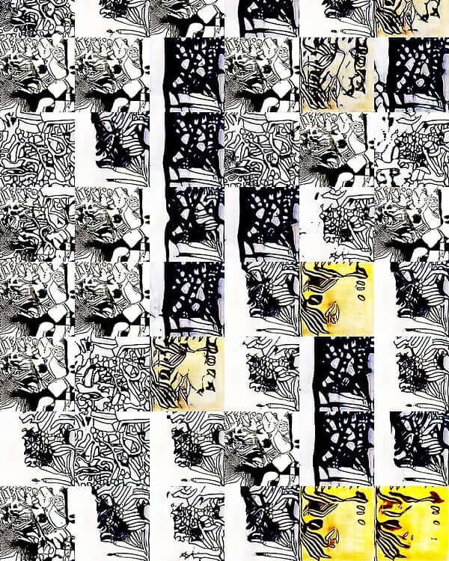

Helena Sarin, *Golden Ratio* (2019), [source](https://www.neuralbricolage.com/)

It is interesting to point out that the development of “AI Art” shares similarities with the development of photography and film as mediums of expression. They started as “tech demos”, went through a phase of emulating traditional media (painting and theater), and eventually broke free to became artistic media in their own right. But Computer Art is probably more specifically and directly related to AI Art. Like AI Artists of today, early Computer Artists were also mostly concerned with multitudes of images. Early computer artists understood the algorithmic production of artistic works as the creation of “generative aesthetics” (plural) i.e. the programmatic creation of the many rules/algorithms associated with the *production* of artistic works.

In support of this view, mathematician, computer scientist and computer art pioneer Frieder Nake (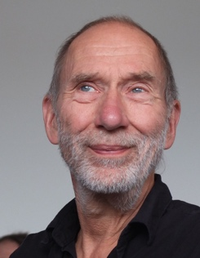) stated that there were *no masterpieces in computer art* and that computer art was not about the production of “pieces” (the art) but more about the production of *system designs* that in turn produced the pieces, and even more so about the beauty and coherence of those designs. Thus, the *method, not the output* was the relevant element for aesthetic judgement.

This strikingly ­lucid observation holds good even today for AI Art and motivates us to regard deep neural network designs from a radically different, “aesthetic” perspective. Indeed, over the last fifty years, the tools to produce such systems have changed, but the notion of “generative aesthetics” has endured.

One of the first artistic applications of machine learning, [Alexander Mordvintsev’s DeepDream](https://ai.googleblog.com/2015/06/inceptionism-going-deeper-into-neural.html) (2015), for instance, is essentially, a system of visual transformation and is based on the visualization of discovered features. DeepDream learns to identify parts of images that resemble other common parts of images (call them archetypes). DeepDream then adds a new step by altering the original image to look more like the archetype of what DeepDream associates with a particular word, which is why it generates, say, a boy festooned with eyeballs 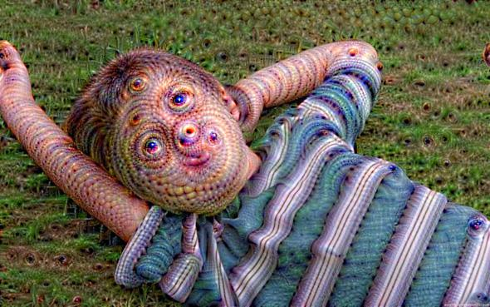

DeepDream can, if asked, “find” an archetype or a feature in an image that is total garbage, as when Google researchers asked it to find *bananas in random noise*. DeepDream located bits and pieces of the noise that matched up the *most*(still not very much) with its banana archetype, then incrementally altered the image to bring the bananas into relief.

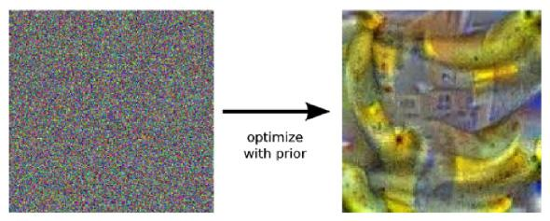

So, while it is true that DeepDream has mostly been used in conjunction with ImageNet/ILSVRC-2012, and has thus produced an overwhelming amount of *dogs*, as a system, DeepDream is not limited to any particular dataset. The reality is that, DeepDream as a system could be used to find anything in anything. In fact, some of the [negative reception to DeepDream](https://psmag.com/environment/googles-deep-dream-is-future-kitsch) could be considered a result of

1. not bringing the system to its full potential by using *different* *datasets*,
2. just presenting samples of output from the system as *full works* without reflecting on their *generative nature*.

This problem, though unfortunate, is not unique to AI Art but an issue with all of media art. Under market pressure this is bound to persist, as recently demonstrated again by the use of DeepDream [as a fashion pattern machine](https://experiments.withgoogle.com/infinitepatterns)!

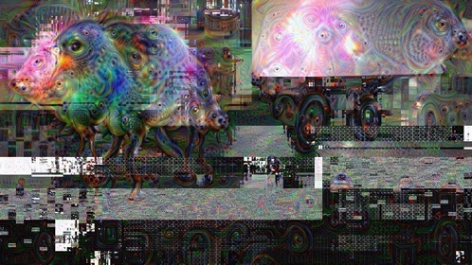

Kyle McDonald, *DeepDream FBO Glitch* (2015).

If we take some of the most popular works labeled as *AI Art* today, it is immediately obvious that they are about *sets of images*. This is not to say that AI Art has not contributed anything new to art or the history of art – just that the underlying philosophical questions of AI art are well known, historical questions rather than questions unique to the present moment in art.

Exactly because it is flawed, the authorship question is almost never promoted by the AI artists themselves. Where it appears, as in the Christie’s auction scandal, it is a pragmatic result of the technological involvement of AI art and its embrace of open source culture: media art and computer art have traditionally not open sourced code/data and have thus not run into similar problems.

# AI and contemporary art

Closely connected to the question of adoption in the art world is the question of critical reception. In a review of the Barbican show, Jonathan Jones [wrote in the Guardian](https://www.theguardian.com/artanddesign/2019/may/15/ai-more-than-human-review-barbican-artificial-intelligence) about Mario Klingemann’s piece Circuit Training:

It’s one of the most boring works of art I’ve ever experienced. The mutant faces are not meaningful or significant in any way. There’s clearly no more “intelligence” behind them than in a photocopier that accidentally produces “interesting” degradations.

This view is similar to the “I don’t really like it cause its different from what I expected!” reaction of the late 1960s to computer generated art. One of the reasons, is of course the difference of systems and artifacts: Klingemann’s work is certainly more than a mere collection of images that can be judged individually. Nevertheless, Jones’ critique (particularly using the photocopier analogy) aims at another specific issue of AI art: *its mimetic quality*.

Mimesis is an aesthetic concept that is as old as philosophical aesthetics itself. It describes the aesthetic process as the production of artifacts that *mimic reality* to a certain degree. Modern art has famously tried to break away from mimesis by experimenting with abstract images first, and then getting rid of images altogether (in conceptual art, for instance). Contemporary art is not about image making and has not been about image making for a long time. While this might seem like an entirely flawed development, particularly to those who admire the accomplished craftsmanship of highly mimetic art (like, for instance, Gustave Caillebotte’s work below), it is in fact nothing more than art becoming critically aware that it is a part of a rapidly changing world after the end of the long 19th century.

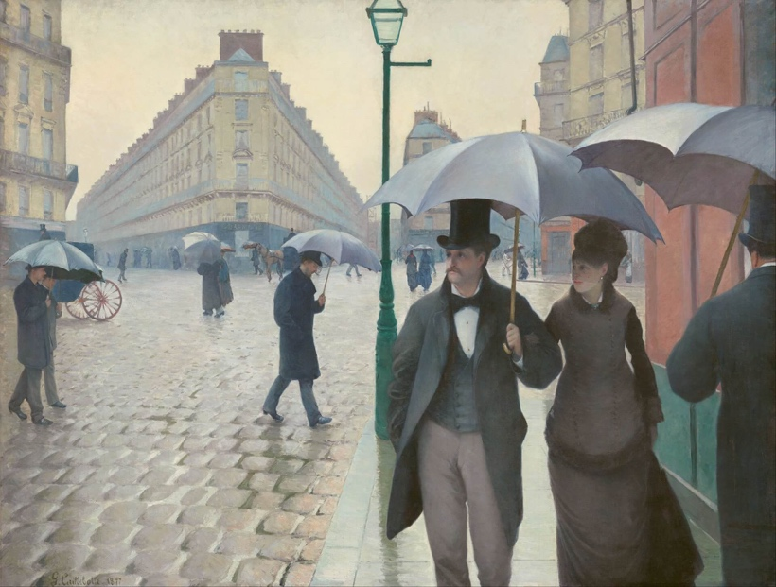

Gustave Caillebotte, *Paris: A Rainy Day* (1877), [source](https://en.wikipedia.org/wiki/Paris_Street%3B_Rainy_Day)

In contrast, *AI art*, in the limited scope discussed here, has the problem that it *is always* *essentially mimetic* even as it is generating. After all, *all* of a neural network’s knowledge about the world comes from the data it processes. “Mimetic” here does not imply that, like (non-abstract) photography, AI art is bound to produce artifacts that can be clearly mapped in a one-to-one fashion to the real world. It is, however, limited to the scope of the *dataset* it operates on. Novelty only happens within this scope. To give a concrete example: a GAN trained on van Gogh painting will certainly produce interesting variations of van-Gogh-like images, but it will never produce an image that, let’s say, reflects on the art historical context of van Gogh’s aesthetics (impressionism). A neural network can never distance itself from the data it operates on, as this data is its entire world, not just one of many subsets of the world, as it is for the human observer.

This is also why the “novelty effect” of artistic demonstrations using machine learning often wears off so quickly. As Zach Lipton [has said](https://www.technologyreview.com/s/613430/this-ai-generated-musak-shows-us-the-limit-of-artificial-creativity/) about MuseNet: it “is uninteresting in precisely the same way as every generic ‘we trained an LSTM to generate __’. I don’t think there is anything here that a musician should find interesting.” Pure mimesis, it turns out, is impressive, but has no lasting aesthetic value. It provides immediate gratification in the easy recognition of similitude, but this quickly wears off. In other words, purely mimetic AI art becomes kitsch fast.

The prominent cases of AI art deals mentioned above fall into this category. Ahmed Elgammal’s pieces are even presented “in elaborate frames” to, “reinforce a connection to the cradle of European art”, as Hoerle-Guggenheim states. Obvious did the same. Both sold what are effectively glitchy versions of historical portraits, a style of work that has not been part of contemporary art for many decades now – except in its dedicated historical reframing of portraits, as in the work of Kehinde Wiley painting “classical, European” portraits of people of color who would never appear in a “European portrait” dataset.

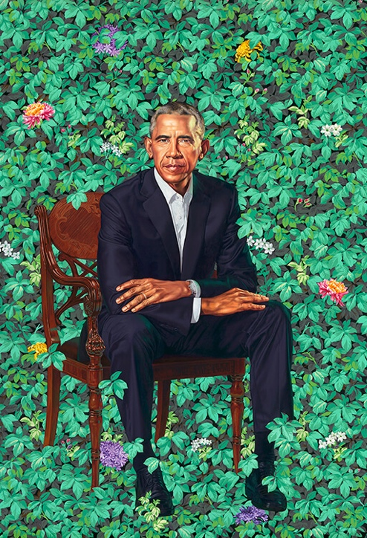

Kehinde Wiley’s portrait of Barack Obama takes up many elements from the European portrait tradition, while at the same time critically transcending this tradition, [source](https://npg.si.edu/exhibition/former-president-barack-obama-artist-kehinde-wiley)

Artists working with AI have realized this, of course, and as a consequence often intentionally work at the mimetic limits of neural networks. The [purely abstract GAN-paintings of Helena Sarin](https://thegradient.pub/playing-a-game-of-ganstruction/), for instance, show that some artists are well aware of these historic implications of their technology of choice. This awareness has a history in computer art itself: Harold Cohen’s Aaron drawing robot, for instance, a multi-decade exploration of pure imitation of style, is the most prominent example of work at the boundaries of the mimetic faculty of machines.

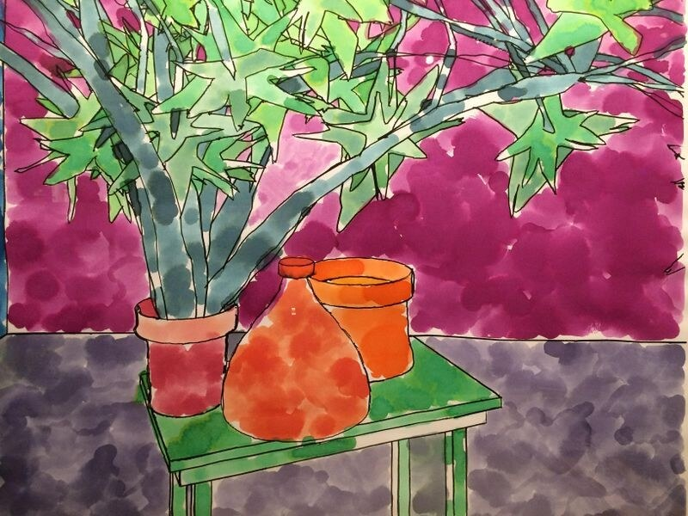Harold Cohen, image created by *AARON* (1995), [source](https://www.computerhistory.org/atchm/harold-cohen-and-aaron-a-40-year-collaboration/)

In the work of Helena Sarin we also find one possible cure for the mimetic disease: the hand-curation of datasets. As pointed out before, if DeepDream [is future kitsch](https://psmag.com/environment/googles-deep-dream-is-future-kitsch) it is future kitsch because it has not been used to its full potential, i.e. outside of ImageNet/ILSVRC-2012. The more interesting/well-curated the datasets, the more interesting/complex the art. Faces will beget faces, ImageNet will beget dogs, but small, custom datasets (in combination with the right selection of techniques) will lead to interesting results - it is indeed (almost) all about the data at this point, as [Sarin herself argued](https://thegradient.pub/playing-a-game-of-ganstruction/).

# The future of AI and Art

While these are exciting times, for science and art, interestingly, neither are we, in the middle of an artistic revolution nor are artists in any danger of being replaced by machines any time soon. It is often overlooked that art progresses much like science does - by building on a history of invention and discovery, sometimes taking incremental steps, sometimes questioning and overthrowing paradigms. Incorporation of AI seems to be an incremental step.

Only time will tell if AI powered art will ever become the revolution that will question the very way, we produce art. It may well turn out that there is no mythical secret sauce required to generate “human” creativity, just ever-increasing layers of complexity and emergent behavior from unanticipated interactions. But from the history of contemporary art in general, and from the history of computer art in particular, there seems to be much more to it. Particularly given the highly human and contextual definition of “meaning” in art.

So, the real importance of DeepDream and other systems of intelligent computational art lies in their grasp of similarity and other analogical processes that contribute to creative generation as well as its trained and stochastic nature. This a welcome departure from the deterministic algorithms that have informed the foundation of computer science as a field of study. Welcome because it brings computer science a step closer to life, humanity and art and hints to the bi-directionally beneficial co-existence of AI and art.

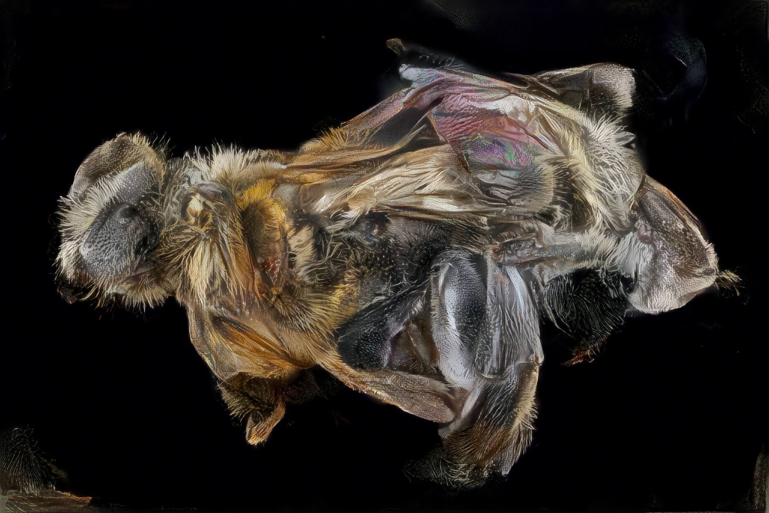Sophia Crespo Neural Zoo (2018)

Artists, being what they are i.e. owners of open, critical minds, will be quick to embrace the *critical potential of AI* i.e. to use AI to criticize itself, as a technology used in the real world. The real power of technologically informed art, is that it can actively instrument and comprehend the act of production and inform the way a certain technology is used or viewed, rather than just providing aesthetic commentary from the sidelines. An example of this viewpoint is that one of the most important articles on GAN-generated faces, [How to recognize fake AI-generated images](https://medium.com/@kcimc/how-to-recognize-fake-ai-generated-images-4d1f6f9a2842) was written by an artist, Kyle McDonald, working with machine learning!

So, looking forward, it could be, that AI will be a driver of *critical* innovation in art much more than a driver of aesthetic innovation. Just as *abstraction* emerged as a *critique* of realism in painting, AI art could become a medium for the critique of “realist” AI, i.e. AI used under the assumption that it is a proper agent in the real world (much like ImageNet is problematically assumed to be a valid and exhaustive sample of the real world).

Much more likely is the continuation of a process we already see today: the slow and steady recuperation of explicit “AI art” by contemporary art. Machine learning, in other words, will add to set of tools that Artists use to create, hopefully, a newer dizzying variety of art. And with this, the philosophical speculations will shift to something else as well.

**But first, A Vector Space Refresher**

Okay, before we get into the technical details of Deep Learning and how it powers intelligent image processing and generation of images that have meaning, we need to understand some of the basic data related needs of the deep learning algorithms. Deep Learning algorithms often rely on certain assumptions about the data being fed in. Ensuring data meet these assumptions is a significant portion of the preparation work before model training and predicting begins. Stuffing everything into a table is a start but it’s just the start! Feeding these naïvely compiled tables into learners and wondering why the algorithms never seem to perform well is a common phenomenon.

These algorithms typically use, what is called, vector space operations as fundamental primitives in their functions. The data needs to comply to the properties expected of vector spaces for these learning functions to work correctly. So, what is a Vector Space? We’ll get to that for sure but for now it suffices to say that Vector spaces are really a neat tool for *organizing data* and require more effort than just getting all your data into a table. Perhaps most mind-bending concept to get used to is that a vector space can be constructed from anything, even if we tend to just use numbers and categorical values.

Now, vector spaces are glossed over because vectors are a much easier concept to grok i.e. a quantity with more than one element (more than one piece of information). For e.g., suppose we are in a room and we move around to different locations to measure the temperature. Temperature at a particular location has just one element (like 22° C). Since temperature only has one piece of information, we call it a scalar. Other examples of scalars would be mass, electric charge, power, electric potential difference.

But then if we go around to different points in the room in order to determine the *air flow*. At each location, air could be moving in three different directions/dimensions (left-right, forward-backward, top-down) or simply (x, y, z). So, to measure the air velocity at each location we would need 3 elements. We call this air flow a vector (a 3-dimensional vector) because it has three pieces of information. Other examples of vectors would be forces, electric fields, acceleration, displacement.

The assumption that a vector space is just a collection of vectors in the same coordinate system and which can be represented as a table is an easy mistake to make. But the catch is that not every collection of vectors conforms to the rules of a vector space! The rules are what makes vector spaces useful – if you don’t conform to the rules, downstream transformations distort the “space” incorrectly. That means the relationships within the vector space will be inconsistent following transformation, and therefore any machine learning algorithm which performs any such transformations is going to be introducing error into the relationships it is trying to learn.

So, let’s look at a brief definition of a vector space: A vector space is any set V on which two operations + and · are defined, called vector addition and scalar multiplication and some additional ten properties hold true. These are properties like, if you add two vectors in a vector space, the sum should also belong to the vector space, you should be able to add two vectors backward and forward and get the same result, if you multiply a vector in a vector space with a constant, the result should also be in the vector space etc. Most of these properties are quite simple but nevertheless need to be obeyed.

To understand this definition further, consider this example. Assume we have data about countries over time for a few measures, like agricultural yield and precipitation. We can represent this data as vectors defined by using the attributes as the coordinate system (or dimensions). Some sample vectors might be:

Vector 1 –  
Country: Atlantis  
Year: 2015  
Agricultural Yield: 5 tons  
Total Precipitation: 100 cm/m2

Vector 2 –  
Country: Avalon  
Year: 2015  
Agricultural Yield: 20 tons  
Total Precipitation: 50 cm/m2

These vectors can be easily written as a table (I added two additional vectors for our example):

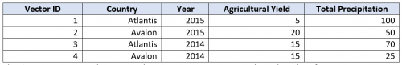

The danger is assuming that we now have a vector space. This is where the rules of a vector space start to matter as there are a few rules that need to be satisfied for it to be considered one. Most of us dealing with empirical data (collected via experiments) do not encounter situations where we need to worry about them. The ones one needs to worry about are “common sense” rules i.e. we must be able to add any combination of vectors (any rows in our table) in any order, and the result must “make sense” and be consistent (i.e. changing the order of addition doesn’t change the result).

The phrase “make sense” is key as it is as much contextual to what the data is about as it is about mathematical precision. We can have a vector space representation of a dataset which follows all the mathematical rules, but which doesn’t make as much sense as the same dataset represented in a different way in another vector space. Even though both vector spaces represent the exact same data, machine learning algorithms will usually be more accurate when trained on the space that “makes the best sense.”

So, what makes sense? Consider the result of adding vectors 1 and 2 from the above table (recall that to add any two vectors just add the values in the same column):



The new vector that is created by the addition of vectors 1 and 2 still lives in the same coordinate system but gives us a strange result. The addition seems to have predicted the rain and yield in the year 4030 for a strange combined country entity called “Atlantis+Avalon”. This doesn’t align with the expectation that when adding the yearly production of two countries I should just get their combined production for the year. The result from adding two rows from our current table doesn’t make sense, so the table can’t be a vector space. Even more telling, if you reverse the order of addition the combined country entity changes, becoming “Avalon+Atlantis”, again violating the vector space rules.

There are several methods to get the vector space we need. Looking at the bad result in the previous example, we see that the issue is with the combined country entity and the future year. The Yield and Precipitation columns seem to have combined in an understandable way. So, our task is to represent the Country and Year dimensions of our vectors differently. Let’s walk through 4 options that will help with our example.

Option 1: One-hot Encoding

One representation option for the problem columns in our example is called “one-hot encoding,” which is a way of taking any enumerated list of values and pivoting the values into dimensions. This means creating a column for every possible value, and using a true/false flag (or 1/0) to represent which value is “active” for a row. Using this method, the prepared table would look like:

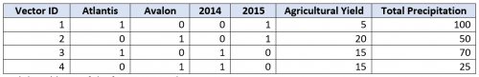

And the addition of the first two rows becomes:



This result is mathematically valid and makes sense… with a little study. We can see that the combined result is from 2 different counties both from 2015. If we reverse the order of the addition the result is the same. So, this is a vector space. Since this still takes a bit of study to really interpret, perhaps another representation should be considered to get the highest-performing model. In this case I don’t like how this space keep countries and years separate from each other with purely binary on/off values. Without discussing the specifics, this makes it harder for an algorithm to learn about relationships between countries in the same year, or between years for the same country. Keep in mind that one-hot encoding creates lots of dimensions, which can dramatically increase model processing resource requirements (time and/or computation) – the curse of dimensionality.

Option 2: Change Coordinate System

Another option could be using a different coordinate system for some of your data points. In our example, the Year is a good candidate for such a transformation if our analysis is really interested in estimating the production from a period of time. In this case, we may not care about the time period’s “name” (i.e. “2015” or “2014), as long as we can predict the correct amount of production from our model for a time period given the other attributes (i.e. “Country” and the other columns from our example). A table with this representation might convert the Year into a duration, and one-hot encode the country:

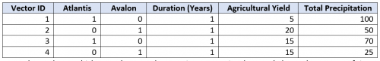

We no longer know which named year each vector is representing, but we do know the amount of time which is represented by each vector. When we add the first two vectors we now get:



This makes sense, but a machine will still have some trouble sorting out the contribution to production from each country during the time period since there isn’t a one-to-one alignment. This issue is mitigated by having lots of year-duration input vectors which, when combined in different groupings, inform the model on individual country contributions to production.

Option 3: Combine Dimensions

Another option could be to combine our columns. For example, the enumerated value columns could have their values distributed to the other columns, creating columns for every combination. Doing this just with Country in our example, and one-hot encoding the Year, this looks like:

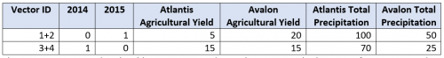

This representation is already adding vectors together and mapping multiple vectors from my original table into a single vector in this table. When we add two vectors together from this latest table we get:

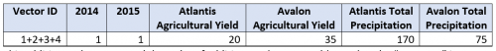

This addition makes sense and the order of addition can be reversed (note that the “Vector ID” is not actually part of our data, just a tracking column). What is good about this representation is that the relationships between countries in a given year can now be learned more easily. We still have trouble learning relationships across years since they are one-hot encoded. A downside of this method is that if we keep creating “combination columns” for every combination of interest we wind up with all of the data in very few really long rows, which is useless since we want lots of rows to for an algorithm to train on. The curse of dimensionality rears its ugly head with this method as well.

Option 4: Tensor Representation

Tensors can be thought of as vector spaces of vector spaces as a vector space can be made of anything. Much like folks will mistake any table for a vector space, people often assume that any multi-dimensional matrix or array is a tensor. This is not the case, because vector space rules must be followed. Vector spaces alone are powerful, but tensors really get to a whole new level of power and are needed to study relativity and quantum mechanics. I am glad we have folks like Einstein who could invent such math, because the leap from a vector space to a dual space would never have occurred to me. For those who find math’s abstraction beautiful, I recommend watching Pavel Grinfeld’s lecture introducing tensors (<https://youtu.be/e0eJXttPRZI>) and the series of lectures on tensors from “XylyXylyX” (<https://youtu.be/_pKxbNyjNe8>).

The downside of using tensors is that most machine learning algorithms are designed to handle low-rank tensors. A tensor’s rank, or order, is the number of dimensions needed to reference a vector in the tensor. A scalar is a rank-0 tensor, a vector is rank-1, a vector space is rank-2, and beyond this, tensors are referred to only by their rank and are considered high-rank tensors. The word “dimension” gets overused in data science, referring to both the number of coordinates in a vector and the number of directions needed to describe a tensor. This is not a big deal because ultimately both concepts refer to an indexing system and can be converted into the other. Squeezing high-rank tensors into low-rank algorithms is a robust area of study, as is the creation of new algorithms to work on high-rank tensors directly.

A tensor representation of our example data can be visually depicted as a collection of tables. This is because a table can only easily show two directions (dimensions) at a time if we don’t want to have arrays in each cell. In our example, we have 3 dimensions – Countries, Years, and Measures. If we make our tables “Measures by Years”, then we will need to have a table for each country. This looks like:

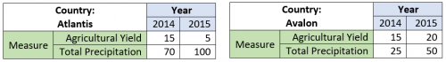

To validate that we are following vector space rules, we can add two vectors specified by any combination of our 3 dimensions. For example, adding (Country=Atlantis, Year=2015, Measure=Yield) and (Country=Avalon, Year=2015, Measure=Yield) results in 5+20, or 25. Since our dimensions are no longer cells in our table, they don’t combine using the same addition that caused our original table problems. However, you might ask where the “Atlantis and Avalon” combination lives in our tensor. The answer is that “Atlantis and Avalon” is an index within our Country dimension, and since the value for that combination doesn’t change with the order they are added, vector space rules are maintained. When materialized using the “Measures by Years” table for each country, the way we visualized our tensor previously, this looks like:

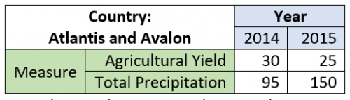

Everything makes sense, at least until you try training working with a low-rank machine learning algorithm. Methods for getting this rank-3 tensor into machine learning algorithms that operate on rank-2 tensors are outside the scope of this discussion. There are some tremendous benefits to working with tensors including being robust against sparsity and dirty data.

Each of the 4 options discussed help a data scientist get from raw source data to a vector space more compatible with machine learning algorithms, and each has pros and cons. The right method will depend on your data, use case, resources (time, compute, and storage availability), and goals. These methods are not mutually exclusive of each other and can be combined in different ways.

Getting a vector space is not always a requirement (for e.g., decision trees don’t need them), and that data preparation is rarely finished once you have a vector space (scaling values, normalizing distributions, and many other feature engineering and selection tasks should be considered). Foundations run deep and relying on a well-built vector space will hold up when we place lots of machine learning machinery on top of it.

**And Now, Latent Spaces:**

Latent space in one sentence means a representation of compressed data. Now, imagine a large dataset of handwritten digits (0–9) like the one shown above. Handwritten images of the same number (i.e. images that are 3’s) are the most similar to each other compared to other images of different numbers (i.e. 3s vs. 7s). But can we train an algorithm to recognize these similarities? *How?* Well, if you have trained a model to *classify digits*, then you have *also* trained the model to learn the ‘structural similarities’ between images. In fact, this is how the model is able to classify digits in the first place- by learning the features of each digit. If it seems that this process is ‘hidden’ from you, it’s because it is. Latent, by definition, means “hidden.” The concept of “latent space” is *important*because its utility is at the core of ‘deep learning’ — *learning the features of data and simplifying data representations for the purpose of finding patterns.*

*Why do we compress data in ML?*

More often than not, data is compressed in machine learning to *learn important information* about data points. The logic here is that not all data contains information that is relevant to a particular context. Data compression is the process of encoding information using fewer bits than the original representation without loss or with minimal loss of information. This is like taking a 19-dimension data point (need 19 values to define unique point) and squishing all that information into a 9-dimension data point.

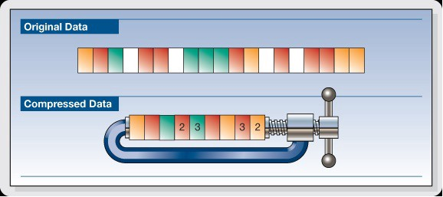

*Illustration of compression. Source: Faust 2013*

Consider this example: Let’s say we would like to train a model to classify an image using a fully convolutional neural network (FCN) (i.e. output digit number given image of digit). As the model ‘learns’, it is simply learning *features* at each layer (edges, angles, etc.) and attributing a combination of features to a specific output. But each time the model learns through a data point, the *dimensionality* of the image is first *reduced* before it is ultimately increased. (see Encoder and Bottleneck below). When the dimensionality is reduced, we consider this a form of lossy compression.

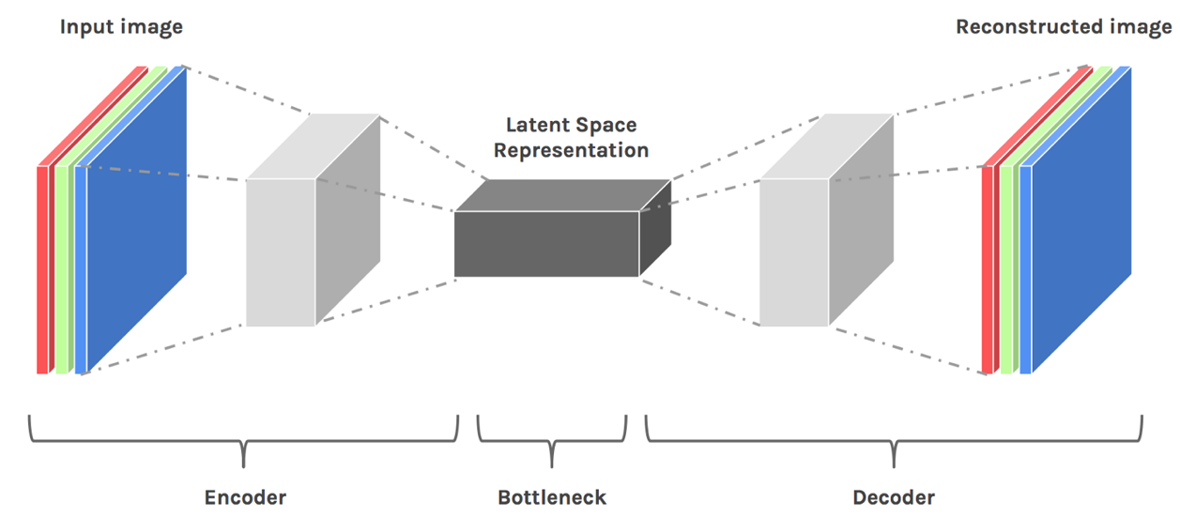

*Depiction of convolutional neural network. Source: Source: Hackernoon Latent Space Visualization.*

Because the model is required to then *reconstruct* the compressed data (see Decoder), it must learn to store *all relevant information*and disregard the noise. This is the value of compression- it allows us to get rid of any extraneous information, and only focus on the most important features. This ‘compressed state’ is the Latent Space Representation of our data.

*What is meant by space?*

You may be wondering why we call it a latent *space*. After all, compressed data, at first glance, may not evoke any sort of “space.” But here’s the thinking. In this rather simplistic example, let’s say our original dataset are images with dimensions 5 x 5 x 1. We will set our latent space dimensions to be 3 x 1, meaning our compressed data point is a vector with 3-dimensions.

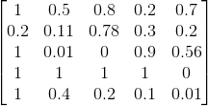

*Example 5x5x1 data*

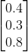

Example compressed 3x1 data in ‘latent space’

Now, each compressed data point is uniquely defined by only 3 numbers. That means we can graph this data on a 3D Plane (One number is x, the other y, the other z).

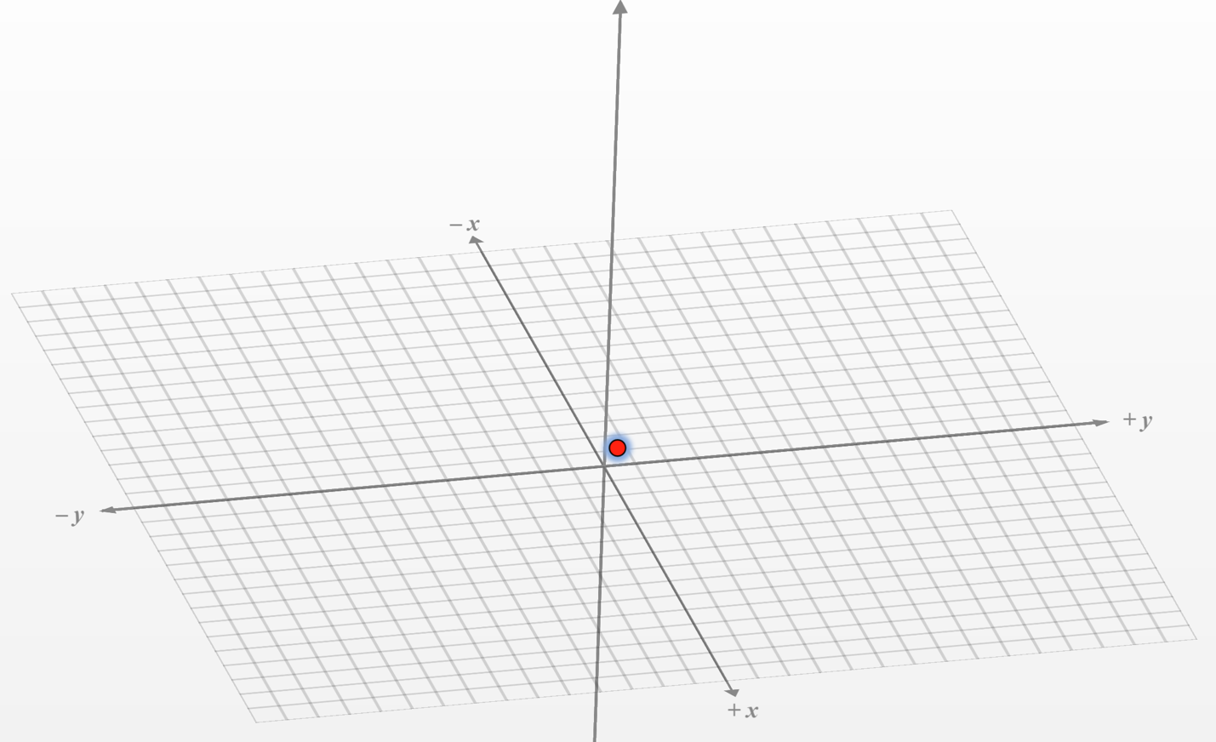

Point (0.4, 0.3, 0.8) graphed in 3D space

This is the “space” that we are referring to.

Whenever we graph points or think of points in latent space, we can imagine them as coordinates in space in which **points that are** “similar”,**are closer together on the graph.** So, how would we imagine a space of 4D points or n-dimensional points, or even non-vectors (since the latent space representation is NOT required to be 2 or 3-dimensional vectors and is oftentimes not since too much information would be lost). We *can’t*. We are 3-dimensional creatures that cannot fathom n-dimensional space (such that n > 3). However, there are tools such as t-SNE which can transform our higher dimensional latent space representations into representations that we *can*visualize (2D or 3D). But then, what *are* ‘similar’ images, and why does reducing the dimensionality of our data make similar images ‘closer’ together in space?

**What is meant by similar?**

If we look at three images, two of a chair and one of a desk, we would easily say that the two chair images are the most *similar* whereas the desk is the most different from either of the chair images.

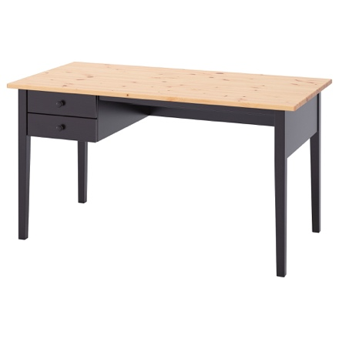

*Two chairs and a desk.*

But what makes these two chair images “more similar?” A chair has *distinguishable features* (i.e. back-rest, no drawer, connections between legs). These can all be ‘understood’ by our models by learning patterns in edges, angles, etc. As explained, such features are packaged in the latent space representation of data. Thus, as dimensionality is reduced, the ‘extraneous’ information which is distinct to each image (i.e. chair color) is ‘removed’ from our latent space representation, since only the most *important* features of each image are stored in the latent space representations. As a result, as we reduce dimensionality, the representations of both chairs become less distinct and more similar. If we were to imagine them in space, they would be ‘closer’ together.

*The ‘closeness’ metric referred to throughout this section is an ambiguous term and *not* a definitive Euclidian distance, because there are multiple definitions of distance in space.

**Why Does Latent Space Matter?**

The latent space concept is intriguing but *how* is it used? *When* do we use it? And most importantly, *why*? What we find is that the latent space is ‘hidden’ in many of our favorite image processing networks, generative models, etc. Although the latent space is hidden from most, there *are* certain tasks in which understanding the latent space is not only helpful, but necessary.

**Representation Learning**

The latent space representation of our data contains all the important information needed to represent our original data point. This representation *must* then represent the **features** of the original data. In other words, the model *learns*the data features and simplifies its representation to make it easier to analyze. This is at the core of a concept called **Representation Learning,**defined as a set of techniques that allow a system to discover the *representations* needed for *feature detection*or *classification* from *raw data.* In this use case, **latent space representations** are used to transform more complex forms of raw data (i.e. images, video), into *simpler representations* which are ‘more convenient to process’ and analyze. Listed below are specific instances of representation learning.

**Manifolds**

The latent space is an essential concept in **manifold learning**, a subfield of representation learning. Manifolds in data science can be understood as groups or subsets of data that are ‘similar’ in some way. *These similarities, usually imperceptible or obscured in higher-dimensional space, can be discovered once our data has been represented in the latent space.* Take the example of a ‘swiss roll’ below.

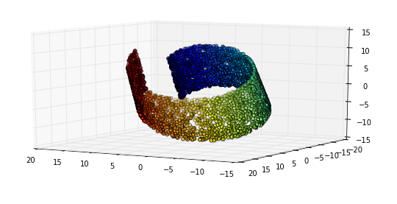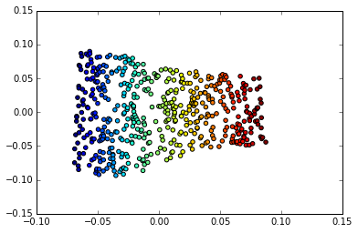

3D Representation of Swiss Roll vs. 2D Representation of same data (<https://datascience.stackexchange.com/a/5698>)

In 3D, we know that there are groups of similar data points that exist, but it is much more difficult to delineate such groups with higher dimensional data. By reducing the dimensionality of our data to 2D, which in this case could be considered a ‘latent space’ representation, we are able to more easily distinguish the manifolds (groups of similar data) in our dataset.

**Autoencoders and Generative Models**

A common type of deep learning model that manipulates the ‘closeness’ of data in the latent space is the **autoencoder —**a neural network that acts as an identity function. In other words, an autoencoder learns to output whatever is inputted.

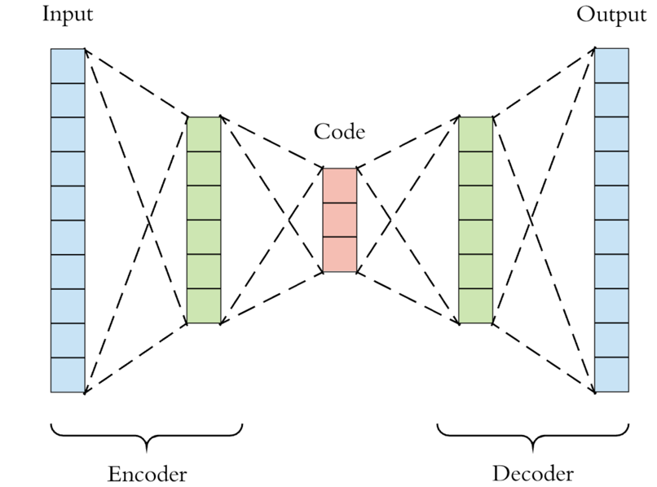

General architecture of an autoencoder

Now, if you’re new to ML, you may be wondering, why in the world would we need a model that does this? It seems rather useless if all it outputs is itself. Though this reasoning is valid, it’s not the output that we care about. We care more about what the model learns in the process. When we force a model to become an identity function, we are forcing it to store all of the data’s relevant features in a *compressed representation* so that there is enough information in that compressed form such that the model can ‘accurately’ reconstruct it. *Sound familiar?*It should, because this compressed representation *is our latent space representation* (red block in image above). We have seen how patterns can be more easily discovered (and manipulated) in the latent space since similar data points will tend to cluster together, but we have not yet seen how we can sample points*from* this latent space to seemingly generate ‘new’ data and that’s where generative models and GANs come in.

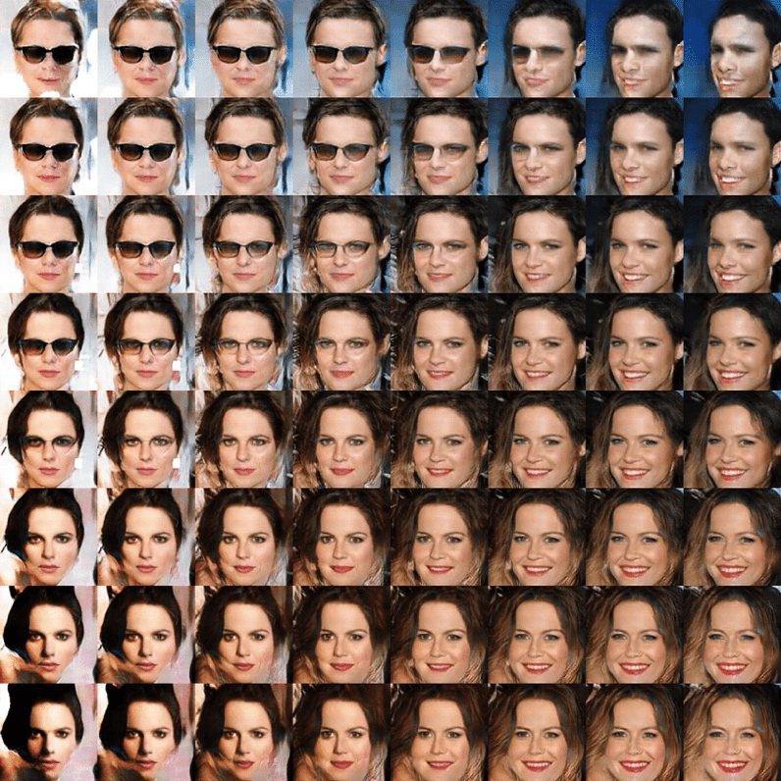

Image generation through latent space interpolation. Source: Bilinear interpolation on latent space for random noise vectors. Figure 20

In the example above, we can generate different facial structures by *interpolating on latent space* and using our model decoder to reconstruct the latent space representation into a 2D image with the same dimensions as our original input. More detail about this later in the section on GANs.

**Interpolation in Latent Space**

Let’s say that I have compressed the chair images from the previous section into the following 2D vectors, [0.4, 0.5] and [0.45, 0.45]. Let’s say the desk is compressed to [0.6, 0.75]. If I were to interpolate on latent space, I would sample points in latent space *between* the ‘chair’ cluster and the ‘desk’ cluster. We can feed these sampled 2D vectors into the model’s decoder, and voila! We get ‘new’ images that look like a morph between a chair and a desk. *new is in quotes because these generated images are not technically independent of the original data sample.

Below is an example of linear interpolation between two types of chairs in latent space.



Interpolation in Latent Space. Source: Hackernoon Latent Space Visualization.

Image generation is still an active area of research, and the latent space is an essential concept that must be understood.

**Visualizing Latent Space**

For more on latent space visualization, I recommend Hackernoon’s article which provides a hands-on example of visualizing similarities between digit images in a 2D space with the t-SNE algorithm.

In summary, the**latent space**is simply *a representation of compressed data in which similar data points are closer together in space*.

* Latent space is useful for learning data features and for finding simpler representations of data for analysis.
* We can understand patterns or structural similarities between data points by analyzing data in the latent space, be it through manifolds, clustering, etc.
* We can interpolate data in the latent space, and use our model’s decoder to ‘generate’ data samples.
* We can visualize the latent space using algorithms such as t-SNE and LLE, which takes our latent space representation and transforms it into 2D or 3D.

**And now, Generative Adversarial Networks (GANs)** 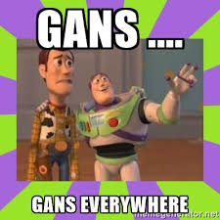

You have probably already heard of GANs in some capacity. One played a central role in the creation of the highly hyped, controversial AI-generated portrait that [sold at Christie’s for $432,500](https://hyperallergic.com/468060/christies-sells-ai-generated-art-for-432500-as-controversy-swirls-over-creators-use-of-copied-code/). GANs are also behind the [recent incidents of deepfakes](https://www.technologyreview.com/s/612501/inside-the-world-of-ai-that-forges-beautiful-art-and-terrifying-deepfakes/). By automating the once-complex task of a video editor to blend and reshape mouths to lip-sync or editing the face of one person onto the body of another, GANs have made it so that creating misleading videos for fun, revenge, or propaganda has never been easier. There’s a deep potential for chaos here.

In the opening of Ways of Seeing, John Berger writes, “The relation between what we see and what we know is never settled.” As AI advances to levels of pattern recognition and generation that match human perception, it will make us feel comfortable in thinking we know what we see in their images. It takes a surrealist reject of an image to remind us that our perception works on a different plane than those of computers. We are poor in information, as we cannot process the sheer amount of data a machine can, but rich in real-world context, something that is still lacking in these systems.

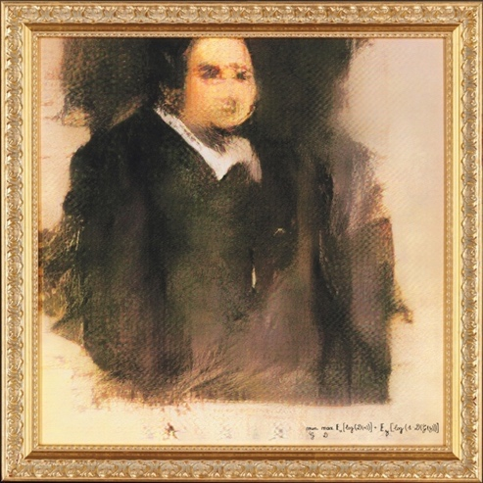

Progress in GANs has been so rapid that today we have hyper-realistic videos by the design agency Canny, [featuring public figures like Kim Kardashian and Mark Zuckerberg](https://petapixel.com/2019/06/12/these-deepfakes-of-famous-people-are-testing-facebooks-policies/) which were created explicitly to spread awareness of the phenomenon and the malicious yet short-lived computer program [DeepNude](https://www.washingtonpost.com/business/2019/06/28/the-world-is-not-yet-ready-deepnude-creator-kills-app-that-uses-ai-fake-naked-images-women/), as examples of implementations that can slip beyond our natural ability to detect fakes. Seeing may not be believing, but exposure to the surreal mistakes these programs make promotes awareness, warning us to expand our critical vision beyond what lays before our eyes.

The origin story of GANs is fairly mundane as origin stories go. In 2014 a PhD student in Yoshua Bengio’s lab, Ian Goodfellow, 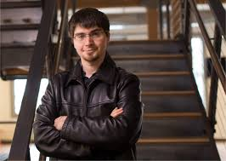 conceived of an algorithm for fabricating realistic-looking images, a technique that Yann LeCun has hailed as the “most important” recent breakthrough in deep learning. The motivation for the idea came at a bar in Montreal called “Les 3 Brasseurs” (). Goodfellow’s friends were describing to him a model they were working on to generate photorealistic images of human faces. They were using traditional machine learning approaches that needed extensive feature engineering viz., cataloguing and approximating critical individual features of faces like eyes, noses, mouths, and accurate estimating how these features should be arranged relative to each other. Even after all this extensive feature preprocessing, their results were poor; the generated faces were either excessively blurry or missing essential elements like a nose or the ears etc. and were looking for ways to improve their model.

Per anecdotes, Goodfellow intuitively grasped the fundamental need i.e. an incrementally learning, correction mechanism that provided feedback to their model thus guiding it to produce better images. He proposed, ostensibly off the cuff, an approach that involved the use of two artificial neural networks that worked against each other like adversaries. One of them would be trained to produce forgeries/fake images and the other trained to detect forgeries from the real ones. As the “detective” network became better and better at detecting forgeries, the “forger” network would in turn have to become better and better at generating forgeries. Not only would this approach result in the generation of convincing images, it would also have the additional benefit of not needing all that cumbersome feature pre-engineering as deep learning would automatically identify the needed features. 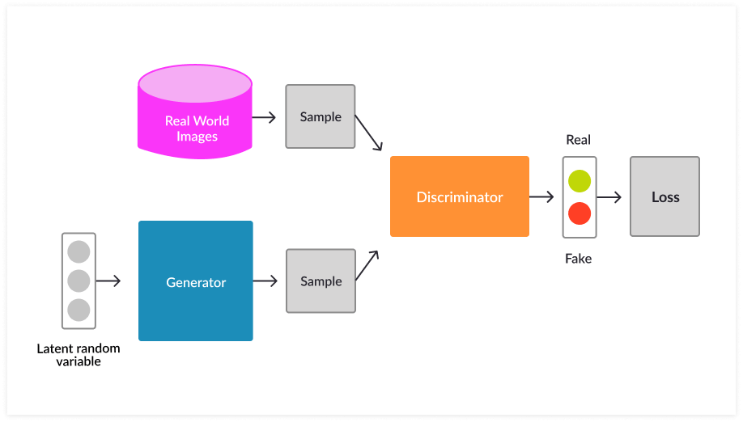 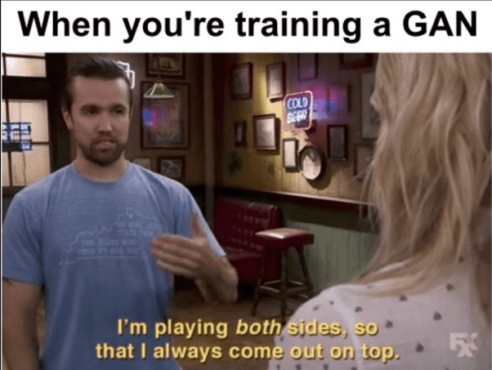

Interestingly, the story and the technical approach has parallels to another important discovery by the American Mathematician John Nash called the Nash equilibrium. The discovery was also made in a bar in an off the cuff fashion. Nash and another student were buying beers for a crowd of graduate students and professors in the bar in the basement of the Nassau Inn, Princeton (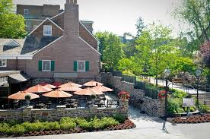) — as tradition demanded of men who had just passed their general exams (qualifiers). 

Game theory considers two theorems as fundamental to the field: von Neumann’s min-max theorem (1928) and Nash’s equilibrium theorem (1950). Von Neumann’s theorem was the cornerstone of his theory of games of pure opposition, so-called two-person zero-sum games. But two-person zero-sum games have virtually no relevance to the real world. Even in war there is almost always something to be gained from cooperation.

Nash introduced the distinction between cooperative and noncooperative games. Cooperative games are games in which players can make enforceable agreements with other players. In other words, as a group they can fully commit themselves to specific strategies. In contrast, in a noncooperative game, such collective commitment is impossible. There are no enforceable agreements. By broadening the theory to include games that involved a mix of cooperation and competition, Nash succeeded in opening the door to applications of game theory to economics, political science, sociology, evolutionary biology and now, GANs. 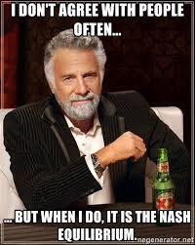

In Generative Adversarial Networks (GANs), the two neural networks compete with each other: the generator (G) tries to trick the classifier (C) into classifying its generated fake data as true and can thus be considered a zero-sum game between two machine players designed to learn the distribution of data.

So, continuing with the GAN origin story, for reasons unknown Goodfellow’s friends were skeptical of his proposal and (maybe) this spurred Goodfellow to return to his apartment and to spend a long night working on his idea to produce a first implementation that, astoundingly, worked! Thus, GAN’s were born. That same year, Goodfellow and his colleagues revealed GANs to the world at the prestigious Neural Information Processing Systems (NIPS) conference. Some of their results are shown in Figure 3.2. Their GAN produced these novel images by being trained on (a) handwritten digits; 7 (b) photos of human faces; and (c) and (d) photos from across ten diverse classes (e.g., planes, cars, dogs). 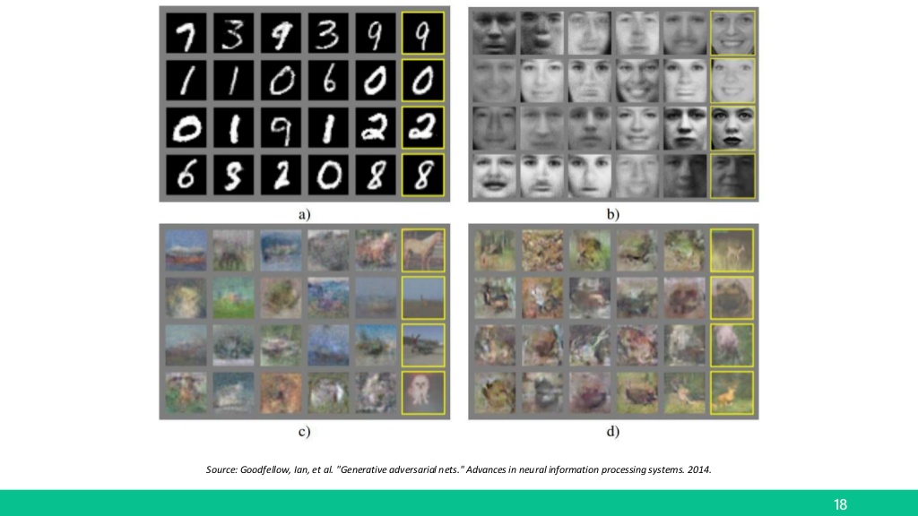

The results in (c) are markedly less crisp than in (d), because the GAN that produced the latter featured neuron layers specialized for machine vision called convolutional layers, whereas the GAN that produced the former used a more general layer type only.

**Convolutions, Latent Spaces, DCGANs & Alec Radford** ()

Picking up from Goodfellow’s work, a research team led by the American machine learning engineer Alec Radford determined important architectural constraints for GANs that guide *considerably more* realistic image creation. Typically, any generative model includes an encoder to map from the feature space (here images of faces) into high dimensional latent spaces. A latent variable is a random variable that we cannot observe directly. A latent space is an n-dimensional space of latent variables.As we learned before, the vector space model is an algebraic model for representing objects as [vectors](https://en.wikipedia.org/wiki/Vector_space) of identifiers, such as, for example, index terms.

Vector space arithmetic can be used in the latent space to perform semantic operations. The model also included a decoder to map from the latent space back into the feature space, where the semantic operations could be observed. Aside: If the latent space transformation was an identity function, we refer to the encoding and decoding as a reconstruction of the input through the model i.e. an Autoencoder.

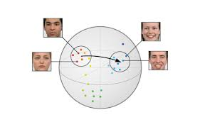

*Latent Space Representations*

Radford and his teammates cleverly demonstrated interpolation through, and arithmetic with, the latent space associated with GANs.

An example of Interpolation:

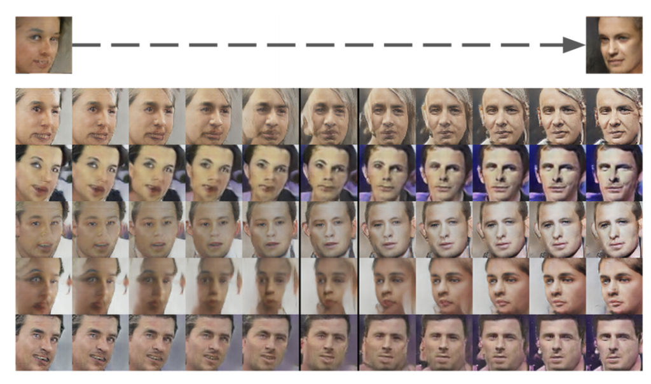

An example of latent-space arithmetic from Radford et al. (2016) 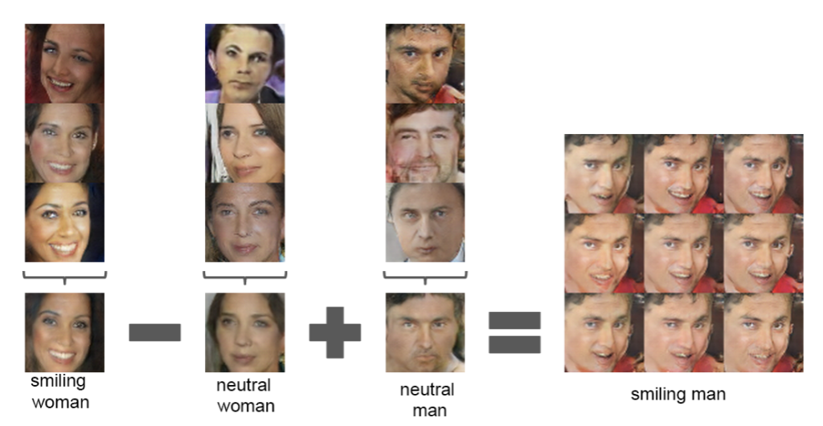

Now, it helps here to restate a few points here about the similarities between latent spaces and vector spaces.

1. *Latent spaces are n-dimensional spaces, usually in the order of hundreds of dimensions*
2. *The closer two points are in the latent space, the more similar the images that those points represent*
3. *Movement through the latent space in any particular direction can correspond to a gradual change in a concept being represented, such as age or gender for the case of photorealistic faces*

By picking two points far away from each other along some n-dimensional axis representing age, interpolating between them, and sampling points from the interpolated line, we could find what appears to be the same (fabricated) man gradually appearing to be older and older. You can see examples of this at bit.ly/ InterpCeleb.

Alec Radford and his team’s work is described as a deep convolutional generative adversarial network, or DCGAN for short. In essence, it is an extension of the GAN architecture using deep convolutional neural networks for both the generator and discriminator models.

— [Unsupervised Representation Learning with Deep Convolutional Generative Adversarial Networks](https://arxiv.org/abs/1511.06434), 2015.

The DCGAN was an important step because it laid out the constraints on the model needed to effectively develop stable, high-quality generator models in practice. This architecture, in turn, provided the basis for the rapid development of a large number of other GAN extensions and applications as you will see shortly.

*We propose and evaluate a set of constraints on the architectural topology of Convolutional GANs that make them stable to train in most settings.*

— [Unsupervised Representation Learning with Deep Convolutional Generative Adversarial Networks](https://arxiv.org/abs/1511.06434), 2015.

### Information Maximizing Generative Adversarial Network (InfoGAN)

We know by now that the Generative Adversarial Network, or GAN for short, is an architecture for training a generative model, such as a model for generating synthetic images. It involves the simultaneous training of the generator model for generating images with a discriminator model that learns to classify images as either real (from the training dataset) or fake (generated). The two models compete in a zero-sum game such that convergence of the training process involves finding a balance between the generator’s skill in generating convincing images and the discriminator’s in being able to detect them.

The generator model takes as input a random point from a latent space, (typically 50 to 100 random Gaussian variables), applies a unique meaning to the points in the latent space via training and maps points to specific output synthetic images. This means that although the latent space is structured by the generator model, *there is no control over the generated image*. The latent space could only be explored and the generated images compared in an attempt to understand the mapping that the generator model has learned.

To overcome this shortcoming, alternative approaches were proposed wherein the generation process could be conditioned, such as via a class label or some such indicator, so that images of a specific type could be created on demand by the Generator. This is in-fact the basis for the Conditional Generative Adversarial Network, CGAN or cGAN for short which is discussed after we discuss the InfoGAN.

Another approach was proposed to provide control variables as input to the generator, along with the point in latent space considered (noise). The generator could then be trained to use the control variables to influence specific properties of the generated images. This is the approach taken with the Information Maximizing Generative Adversarial Network, or InfoGAN for short.

In short, InfoGAN is an information-theoretic extension to the Generative Adversarial Network that is able to learn disentangled representations in a completely unsupervised manner. The structured mapping learned by the generator during the training process is somewhat random. Although the generator model learns to spatially separate properties of generated images in the latent space, there is no control. The properties are entangled. The InfoGAN is motivated by the desire to *disentangle* the properties of generated images. For example, in the case of faces, the properties of generating a face can be disentangled and controlled, such as the shape of the face, hair color, hairstyle, and so on.

*For example, for a dataset of faces, a useful disentangled representation may allocate a separate set of dimensions for each of the following attributes: facial expression, eye color, hairstyle, presence or absence of eyeglasses, and the identity of the corresponding person.*

— [InfoGAN: Interpretable Representation Learning by Information Maximizing Generative Adversarial Nets](https://arxiv.org/abs/1606.03657), 2016.

So, control variables are provided along with the noise as input to the generator and the model is trained via a mutual information loss function.

*… we present a simple modification to the generative adversarial network objective that encourages it to learn interpretable and meaningful representations. We do so by maximizing the mutual information between a fixed small subset of the GAN’s noise variables and the observations, which turns out to be relatively straightforward.*

— [InfoGAN: Interpretable Representation Learning by Information Maximizing Generative Adversarial Nets](https://arxiv.org/abs/1606.03657), 2016.

Mutual Information refers to the amount of information learned about one variable *given another variable*. In this case, we are interested in the information about the control variables given the image generated using noise and the control variables. In information theory, mutual information between X and Y, I (X; Y), measures the “*amount of information*” learned from knowledge of random variable Y about the other random variable X. It can be thought of as the reduction in uncertainty about one random variable given knowledge of another.

Training the generator via mutual information is achieved through the use of a new model, referred to as Q or the auxiliary model. The new model shares all of the same weights as the discriminator model for interpreting an input image, but unlike the discriminator model that predicts whether the image is real or fake, the auxiliary model predicts the control codes that were used to generate the image.

Both models are used to update the generator model, first to improve the likelihood of generating images that fool the discriminator model, and second to improve the mutual information between the control codes used to generate an image and the auxiliary model’s prediction of the control codes.

The result is that the generator model is regularized via mutual information loss such that the control codes capture salient properties of the generated images and, in turn, can be used to control the image generation process.

**Conditional GANs and Photorealism**

**Conditional GANs** ([**CGANs**](https://arxiv.org/abs/1411.1784)) are an extension of the GAN model. **CGANs are**allowed to generate images that have certain conditions or attributes associated with them.

Like GANs**, Conditional GANs**also have two components.

* A **Generator(**An artist**)**neural network.
* A **Discriminator(**An art critic**)**neural network.

In **Conditional GANs** (**CGANs**), **Generator** and **Discriminator**both, receive some additional conditioning input information. This could be the class of the current image or some other property. For example, if we train a GAN to generate new images, there is no control over which specific digits will be produced by the **Generator**. There is no mechanism to request a particular digit from the **Generator**. This problem can be addressed by a variation of GAN called **Conditional GAN** (**CGAN**). We add an additional input layer with values of one-hot-encoded image labels. In conditional GANs (CGANs), adding a vector of features controls the output and guides the **Generator**in figuring out what to do. Such a vector of features should derive from an image which encodes the class(like an image of a woman or a man if we are trying to create faces of imaginary actors) or a set of specific characteristics we expect from the image (in case of imaginary actors, it could be the type of hair, eyes or complexion). We can incorporate the information into the images that will be learned and also into the *Z* input, which is not completely random anymore. The **Discriminator’s**evaluation is done not only on the similarity between fake data and original data but also on the correspondence of the fake data image to its input label (or features)

We can use the same DCGANs and imposed a condition on both **Generator’s**and **Discriminator’s** inputs. The condition should be in the form of a one-hot vector version of the digit. This is associated with the image to Generator or Discriminator as real or fake. CGANs have one disadvantage. CGANs are not strictly unsupervised as we need some kind of labels for them to work.

High-Level CGAN Architecture Diagram

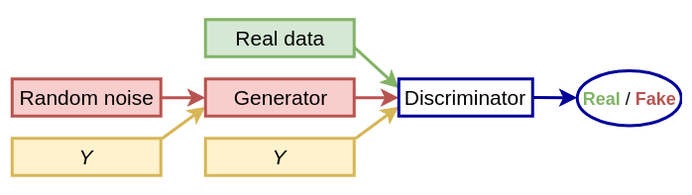

**Conditional GAN**

The Discriminator Network

*The CGAN***Discriminator’s***model is similar to DCGAN***Discriminator’s***model except for the one-hot vector, which is used to condition***Discriminator***outputs.*You can read about **Discriminator’s** Network in my previous post [here](https://medium.com/datadriveninvestor/deep-convolutional-generative-adversarial-networks-dcgans-3176238b5a3d)

The Generator Network

*The CGAN***Generator’s***model is similar to DCGAN***Generator’s***model except for the one-hot vector, which is used to condition***Generator***outputs.*You can read about **Generator’s**Network in my previous post [here](https://medium.com/datadriveninvestor/deep-convolutional-generative-adversarial-networks-dcgans-3176238b5a3d)

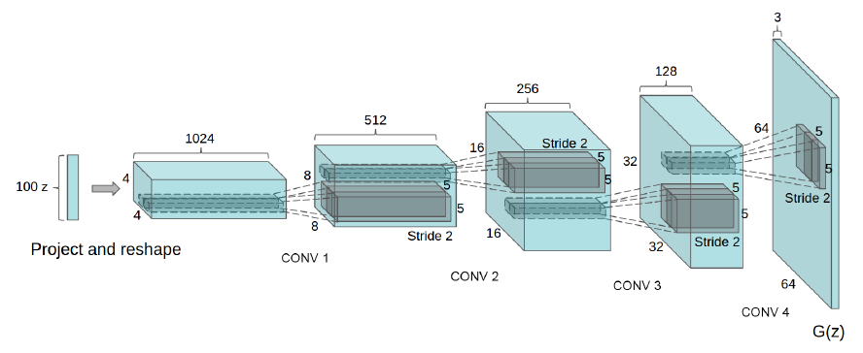

The DCGAN architecture of the **generator**<https://arxiv.org/pdf/1511.06434.pdf>

CGAN’s Architecture Diagram

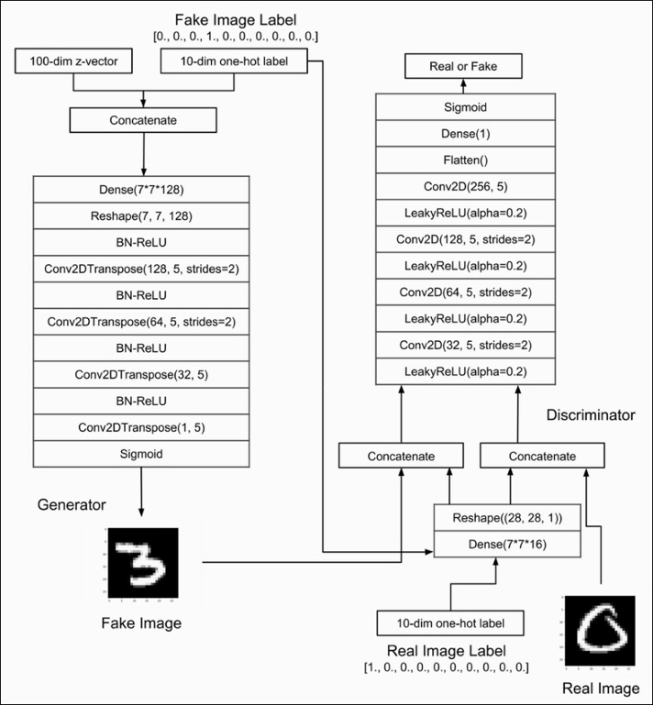

*CGAN’s Architecture*

**The Discriminator has two tasks**: It has tocorrectly label real images which are coming from training data set as “*real*” and correctly label generated images which are coming from **Generator**as “*fake”*. So, we need to calculate two losses for the **Discriminator. The sum of the “***fake”***image and “***real”***image loss is the overall Discriminator loss***. So,* the loss function of the **Discriminator** is aiming at minimizing the error of predicting real images coming from the dataset and fake images coming from the **Generator** *given* their one-hot labels.

**The Generator network has one task:** To create an image that looks as “real” as possible to fool the Discriminator. The loss function of the Generator minimizes the correct prediction of the Discriminator on fake images conditioned on the specified one-hot labels.

*CGANs*can be used to build a model which can generate an image of an imaginary actor of given class like male or female. It can also use to build [*Face Aging*](https://arxiv.org/pdf/1702.01983.pdf)system*,*Age synthesis and age progression have many practical industrial and consumer applicationslike cross-age face recognition, finding lost children, entertainment, visual effects in movies.

### Auxiliary Classifier Generative Adversarial Network (AC-GAN)

The auxiliary classifier generative adversarial network, or AC-GAN, is an extension to the GAN that both changes the generator to be class conditional as with the cGAN and adds an additional or auxiliary model to the discriminator that is trained to reconstruct the class label.

*… we introduce a model that combines both strategies for leveraging side information. That is, the model proposed below is class conditional, but with an auxiliary decoder that is tasked with reconstructing class labels.*

— [Conditional Image Synthesis With Auxiliary Classifier GANs](https://arxiv.org/abs/1610.09585), 2016.

This architecture means that the discriminator both predicts the likelihood of the image given the class label and the class label given the image.

*The discriminator gives both a probability distribution over sources and a probability distribution over the class labels, P(S | X), P(C | X) = D(X).*

— [Conditional Image Synthesis With Auxiliary Classifier GANs](https://arxiv.org/abs/1610.09585), 2016.

### Stacked Generative Adversarial Network (StackGAN)

The stacked generative adversarial network, or StackGAN, is an extension to the GAN to generate images from text using a hierarchical stack of conditional GAN models.

*… we propose Stacked Generative Adversarial Networks (StackGAN) to generate 256×256 photo-realistic images conditioned on text descriptions.*

— [StackGAN: Text to Photo-realistic Image Synthesis with Stacked Generative Adversarial Networks](https://arxiv.org/abs/1612.03242), 2016.

The architecture is comprised of a series of text- and image-conditional GAN models. The first level generator (Stage-I GAN) is conditioned on text and generates a low-resolution image. The second level generator (Stage-II GaN) is conditioned both on the text and on the low-resolution image output by the first level and outputs a high-resolution image.

*Low-resolution images are first generated by our Stage-I GAN. On the top of our Stage-I GAN, we stack Stage-II GAN to generate realistic high-resolution (e.g., 256×256) images conditioned on Stage-I results and text descriptions. By conditioning on the Stage-I result and the text again, Stage-II GAN learns to capture the text information that is omitted by Stage-I GAN and draws more details for the object*

— [StackGAN: Text to Photo-realistic Image Synthesis with Stacked Generative Adversarial Networks](https://arxiv.org/abs/1612.03242), 2016.

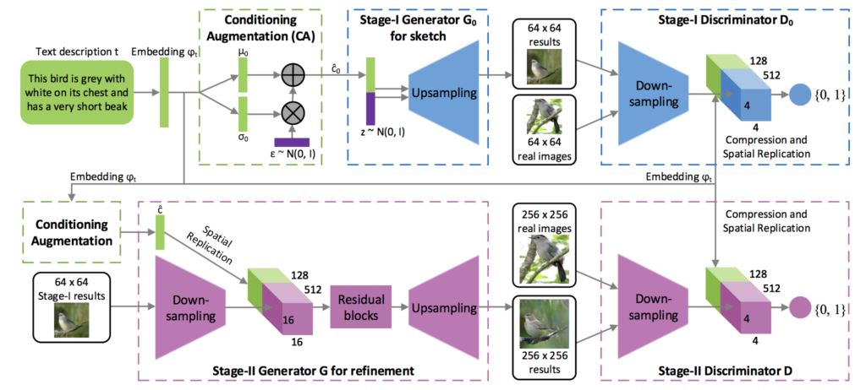

Example of the Architecture for the Stacked Generative Adversarial Network for Text to Image Generation.  
Taken from: StackGAN: Text to Photo-realistic Image Synthesis with Stacked Generative Adversarial Networks.

### Context Encoders

The Context Encoders model is an encoder-decoder model for conditional image generation trained using the adversarial approach devised for GANs. Although it is not referred to in the paper as a GAN model, it has many GAN features.

*By analogy with auto-encoders, we propose Context Encoders – a convolutional neural network trained to generate the contents of an arbitrary image region conditioned on its surroundings.*

— [Context Encoders: Feature Learning by Inpainting](https://arxiv.org/abs/1604.07379), 2016.

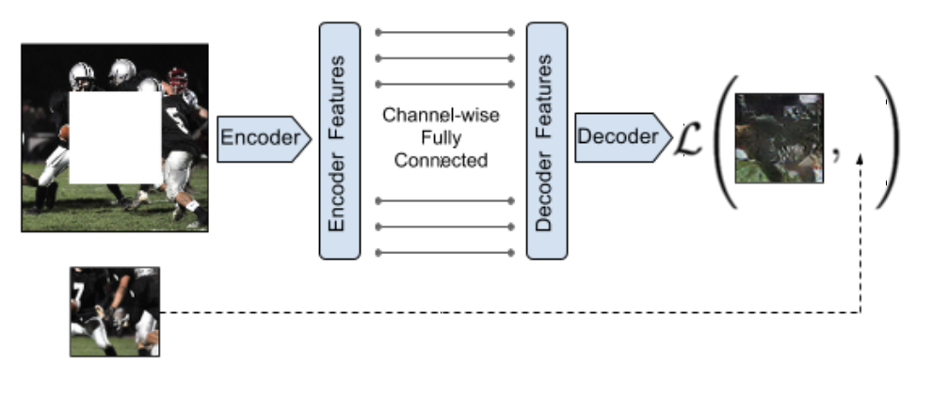

Example of the Context Encoders Encoder-Decoder Model Architecture.  
Taken from: Context Encoders: Feature Learning by Inpainting

The model is trained with a joint-loss that combines both the adversarial loss of generator and discriminator models and the reconstruction loss that calculates the vector norm distance between the predicted and expected output image.

*When training context encoders, we have experimented with both a standard pixel-wise reconstruction loss, as well as a reconstruction plus an adversarial loss. The latter produces much sharper results because it can better handle multiple modes in the output.*

— [Context Encoders: Feature Learning by Inpainting](https://arxiv.org/abs/1604.07379), 2016.

### Pix2Pix

The pix2pix model is an extension of the GAN for image-conditional image generation, referred to as the task image-to-image translation. A U-Net model architecture is used in the generator model, and a PatchGAN model architecture is used as the discriminator model.

*Our method also differs from the prior works in several architectural choices for the generator and discriminator. Unlike past work, for our generator we use a “U-Net”-based architecture, and for our discriminator we use a convolutional “PatchGAN” classifier, which only penalizes structure at the scale of image patches.*

— [Image-to-Image Translation with Conditional Adversarial Networks](https://arxiv.org/abs/1611.07004), 2016.

The loss for the generator model is updated to also include the vector distance from the target output image.

*The discriminator’s job remains unchanged, but the generator is tasked to not only fool the discriminator but also to be near the ground truth output in an L2 sense. We also explore this option, using L1 distance rather than L2 as L1 encourages less blurring.*

— [Image-to-Image Translation with Conditional Adversarial Networks](https://arxiv.org/abs/1611.07004), 2016.

## Advanced Generative Adversarial Networks

This section lists those GAN models that have recently led to surprising or impressive results, building upon prior GAN extensions. These models mostly focus on developments that allow for the generation of large photorealistic images.

### Wasserstein Generative Adversarial Network (WGAN)

The Wasserstein generative adversarial network, or WGAN for short, is an extension to the GAN that changes the training procedure to update the discriminator model, now called a critic, many more times than the generator model for each iteration. The critic is updated to output a real-value (linear activation) instead of a binary prediction with a sigmoid activation, and the critic and generator models are both trained using “*Wasserstein loss*,” which is the average of the product of real and predicted values from the critic, designed to provide linear gradients that are useful for updating the model.

**CycleGANs and Image to Image Translation**

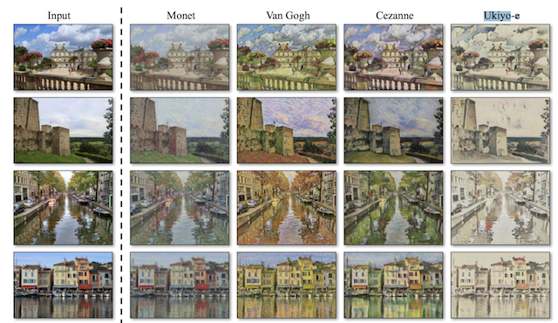

Image-to-image translation involves generating a new synthetic version of a given image with a specific modification, such as translating a summer landscape to winter. Training a model for image-to-image translation typically requires a large dataset of paired examples. These datasets can be difficult and expensive to prepare, and in some cases impossible, such as photographs of paintings by long dead artists.

The CycleGAN is a technique that involves the automatic training of image-to-image translation models without paired examples. The models are trained in an unsupervised manner using a collection of images from the source and target domain that do not need to be related in any way. This simple technique is powerful, achieving visually impressive results on a range of application domains including translating photographs of horses to zebra, and the reverse.

## The Problem with Image-to-Image Translation

Image-to-image translation is an image synthesis task that requires the generation of a new image that is a controlled modification of a given image.

*Image-to-image translation is a class of vision and graphics problems where the goal is to learn the mapping between an input image and an output image using a training set of aligned image pairs.*

— [Unpaired Image-to-Image Translation using Cycle-Consistent Adversarial Networks](https://arxiv.org/abs/1703.10593), 2017.

Examples of image-to-image translation include:

Translating summer landscapes to winter landscapes (or the reverse).

Translating paintings to photographs (or the reverse).

Translating horses to zebras (or the reverse).

Traditionally, training an image-to-image translation model requires a dataset comprised of paired examples. That is, a large dataset of many examples of input images X (e.g. summer landscapes) and the same image with the desired modification that can be used as an expected output image Y (e.g. winter landscapes).

The requirement for a paired training dataset is a limitation. These datasets are challenging and expensive to prepare, e.g. photos of different scenes under different conditions.

In many cases, the datasets simply do not exist, such as famous paintings and their respective photographs.

*However, obtaining paired training data can be difficult and expensive. […] Obtaining input-output pairs for graphics tasks like artistic stylization can be even more difficult since the desired output is highly complex, typically requiring artistic authoring. For many tasks, like object transfiguration (e.g., zebra <-> horse), the desired output is not even well-defined.*

— [Unpaired Image-to-Image Translation using Cycle-Consistent Adversarial Networks](https://arxiv.org/abs/1703.10593), 2017.

As such, there is a desire for techniques for training an image-to-image translation system that does not require paired examples. Specifically, where any two collections of unrelated images can be used and the general characteristics extracted from each collection and used in the image translation process.

For example, to be able to take a large collection of photos of summer landscapes and a large collection of photos of winter landscapes with unrelated scenes and locations as the first location and be able to translate specific photos from one group to the other. This is called the problem of unpaired image-to-image translation.

## Unpaired Image-to-Image Translation With CycleGAN

A successful approach for unpaired image-to-image translation is CycleGAN. CycleGAN is an approach to training image-to-image translation models using the generative adversarial network, or GAN, model architecture.

*[…] we present a method that can learn to [capture] special characteristics of one image collection and figuring out how these characteristics could be translated into the other image collection, all in the absence of any paired training examples.*

— [Unpaired Image-to-Image Translation using Cycle-Consistent Adversarial Networks](https://arxiv.org/abs/1703.10593), 2017.

The GAN architecture is an approach to training a model for image synthesis that is comprised of two models: a generator model and a discriminator model. The generator takes a point from a latent space as input and generates new plausible images from the domain, and the discriminator takes an image as input and predicts whether it is real (from a dataset) or fake (generated). Both models are trained in a game, such that the generator is updated to better fool the discriminator and the discriminator is updated to better detect generated images.

The CycleGAN is an extension of the GAN architecture that involves the simultaneous training of two generator models and two discriminator models.

One generator takes images from the first domain as input and outputs images for the second domain, and the other generator takes images from the second domain as input and generates images for the first domain. Discriminator models are then used to determine how plausible the generated images are and update the generator models accordingly.

This extension alone might be enough to generate plausible images in each domain, but not sufficient to generate translations of the input images.

*… adversarial losses alone cannot guarantee that the learned function can map an individual input xi to a desired output yi*

— [Unpaired Image-to-Image Translation using Cycle-Consistent Adversarial Networks](https://arxiv.org/abs/1703.10593), 2017.

The CycleGAN uses an additional extension to the architecture called cycle consistency. This is the idea that an image output by the first generator could be used as input to the second generator and the output of the second generator should match the original image. The reverse is also true: that an output from the second generator can be fed as input to the first generator and the result should match the input to the second generator.

Cycle consistency is a concept from machine translation where a phrase translated from English to French should translate from French back to English and be identical to the original phrase. The reverse process should also be true.

*… we exploit the property that translation should be “cycle consistent”, in the sense that if we translate, e.g., a sentence from English to French, and then translate it back from French to English, we should arrive back at the original sentence*

— [Unpaired Image-to-Image Translation using Cycle-Consistent Adversarial Networks](https://arxiv.org/abs/1703.10593), 2017.

The CycleGAN encourages cycle consistency by adding an additional loss to measure the difference between the generated output of the second generator and the original image, and the reverse. This acts as a regularization of the generator models, guiding the image generation process in the new domain toward image translation.

## What Is the CycleGAN Model Architecture

At first glance, the architecture of the CycleGAN appears complex. So, let’s take a moment to step through all of the models involved and their inputs and outputs.

Consider the problem where we are interested in translating images from summer to winter and winter to summer. We have two collections of photographs and they are unpaired, meaning they are photos of different locations at different times; we don’t have the exact same scenes in winter and summer.

**Collection 1**: Photos of summer landscapes.

**Collection 2**: Photos of winter landscapes.

We will develop an architecture of two GANs, and each GAN has a discriminator and a generator model, meaning there are four models in total in the architecture. The first GAN will generate photos of winter given photos of summer, and the second GAN will generate photos of summer given photos of winter.

**GAN 1**: Translates photos of summer (collection 1) to winter (collection 2).

**GAN 2**: Translates photos of winter (collection 2) to summer (collection 1).

Each GAN has a conditional generator model that will synthesize an image given an input image. And each GAN has a discriminator model to predict how likely the generated image is to have come from the target image collection. The discriminator and generator models for a GAN are trained under normal adversarial loss like a standard GAN model.

We can summarize the generator and discriminator models from GAN 1 as follows:

**Generator Model 1:**

**Input**: Takes photos of summer (collection 1).

**Output**: Generates photos of winter (collection 2).

**Discriminator Model 1**:

**Input**: Takes photos of winter from collection 2 and output from Generator Model 1.

**Output**: Likelihood of image is from collection 2.

Similarly, we can summarize the generator and discriminator models from GAN 2 as follows:

**Generator Model 2**:

**Input**: Takes photos of winter (collection 2).

**Output**: Generates photos of summer (collection 1).

**Discriminator Model 2**:

**Input**: Takes photos of summer from collection 1 and output from Generator Model 2.

**Output**: Likelihood of image is from collection 1.

So far, the models are sufficient for generating plausible images in the target domain but are not *translations* of the input image. So, each of the GANs are also updated using cycle consistency loss. This is designed to encourage the synthesized images in the target domain that are translations of the input image. Cycle consistency loss compares an input photo to the Cycle GAN to the generated photo and calculates the difference between the two, e.g. using the [L1 norm](https://machinelearningmastery.com/vector-norms-machine-learning/) or summed absolute difference in pixel values.

There are two ways in which cycle consistency loss is calculated and used to update the generator models each training iteration.

The first GAN (GAN 1) will take an image of a summer landscape, generate image of a winter landscape, which is provided as input to the second GAN (GAN 2), which in turn will generate an image of a summer landscape. The cycle consistency loss calculates the difference between the image input to GAN 1 and the image output by GAN 2 and the generator models are updated accordingly to reduce the difference in the images.

This is a forward-cycle for cycle consistency loss. The same process is related in reverse for a backward cycle consistency loss from generator 2 to generator 1 and comparing the original photo of winter to the generated photo of winter.

**Forward Cycle Consistency Loss**:

Input photo of summer (collection 1) to GAN 1

Output photo of winter from GAN 1

Input photo of winter from GAN 1 to GAN 2

Output photo of summer from GAN 2

Compare photo of summer (collection 1) to photo of summer from GAN 2

**Backward Cycle Consistency Loss**:

Input photo of winter (collection 2) to GAN 2

Output photo of summer from GAN 2

Input photo of summer from GAN 2 to GAN 1

Output photo of winter from GAN 1

Compare photo of winter (collection 2) to photo of winter from GAN 1

## Applications of CycleGAN

The CycleGAN approach is presented with many impressive applications.

*Note: If you navigate to bit.ly/ cycleGAN, you’ll be able to see instances of these example applications*

### Style Transfer

Style transfer refers to the learning of artistic style from one domain, often paintings, and applying the artistic style to another domain, such as photographs. The CycleGAN is demonstrated by applying the artistic style from [Monet](https://en.wikipedia.org/wiki/Claude_Monet), [Van Gogh](https://en.wikipedia.org/wiki/Vincent_van_Gogh), [Cezanne](https://en.wikipedia.org/wiki/Paul_C%C3%A9zanne), and [Ukiyo-e](https://en.wikipedia.org/wiki/Ukiyo-e) to photographs of landscapes.



Example of Style Transfer from Famous Painters to Photographs of Landscapes.  
Taken from: Unpaired Image-to-Image Translation Using Cycle-Consistent Adversarial Networks.

**Object Transfiguration**

Object transfiguration refers to the transformation of objects from one class, such as dogs into another class of objects, such as cats. The CycleGAN is demonstrated transforming photographs of horses into zebras and the reverse: photographs of zebras into horses. This type of transfiguration makes sense given that both horse and zebras look similar in size and structure, except for their coloring.

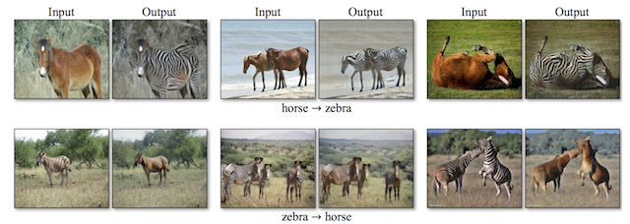

Example of Object Transfiguration from Horses to Zebra and Zebra to Horses.  
Taken from: Unpaired Image-to-Image Translation Using Cycle-Consistent Adversarial Networks.

The CycleGAN is also demonstrated on translating photographs of apples to oranges, as well as the reverse: photographs of oranges to apples.

Again, this transfiguration makes sense as both oranges and apples have the same structure and size.

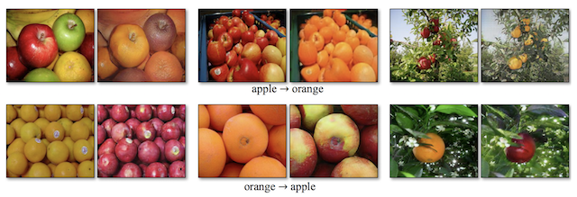

Example of Object Transfiguration from Apples to Oranges and Oranges to Apples.  
Taken from: Unpaired Image-to-Image Translation Using Cycle-Consistent Adversarial Networks.

**Season Transfer**

Season transfer refers to the translation of photographs taken in one season, such as summer, to another season, such as winter. The CycleGAN is demonstrated on translating photographs of winter landscapes to summer landscapes, and the reverse of summer landscapes to winter landscapes.

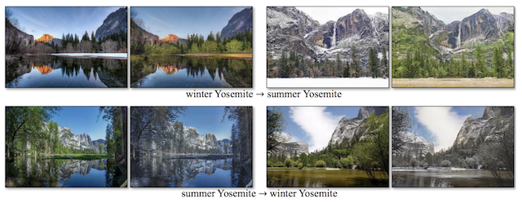

Example of Season Transfer from Winter to Summer and Summer to Winter  
Taken from: Unpaired Image-to-Image Translation Using Cycle-Consistent Adversarial Networks.

**Photograph Generation From Paintings**

Photograph generation from paintings, as its name suggests, is the synthesis of photorealistic images given a painting, typically by a famous artist or famous scene. The CycleGAN is demonstrated on translating many paintings by Monet to plausible photographs.

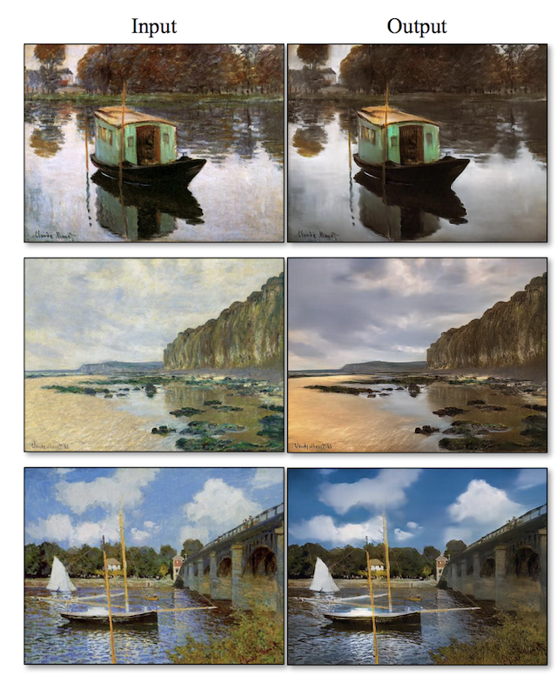

Example of Translation Paintings by Monet to Photorealistic Scenes.  
Taken from: Unpaired Image-to-Image Translation Using Cycle-Consistent Adversarial Networks.

**Photograph Enhancement**

Photograph enhancement refers to transforms that improve the original image in some way. The CycleGAN is demonstrated on photo enhancement by improving the depth of field (e.g. giving a macro effect) on close-up photographs of flowers.

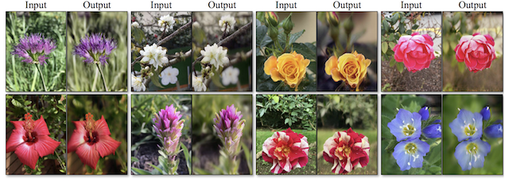

Example of Photograph Enhancement Improving the Depth of Field on Photos of Flowers.  
Taken from: Unpaired Image-to-Image Translation Using Cycle-Consistent Adversarial Networks.

### Progressive Growing Generative Adversarial Network (Progressive GAN)

The progressive growing generative adversarial network, or Progressive GAN for short, is a change to the architecture and training of GAN models that involves progressively increasing the model depth during the training process.

*The key idea is to grow both the generator and discriminator progressively: starting from a low resolution, we add new layers that model increasingly fine details as training progresses. This both speeds the training up and greatly stabilizes it, allowing us to produce images of unprecedented quality …*

— [Progressive Growing of GANs for Improved Quality, Stability, and Variation](https://arxiv.org/abs/1710.10196), 2017.

*This is achieved by keeping the generator and discriminator symmetric in depth during training and adding layers step-wise, much like the greedy layer-wise pretraining technique in the early developing of deep neural networks, except weights in prior layers are not frozen.*

*We use generator and discriminator networks that are mirror images of each other and always grow in synchrony. All existing layers in both networks remain trainable throughout the training process. When new layers are added to the networks, we fade them in smoothly …*

— [Progressive Growing of GANs for Improved Quality, Stability, and Variation](https://arxiv.org/abs/1710.10196), 2017.

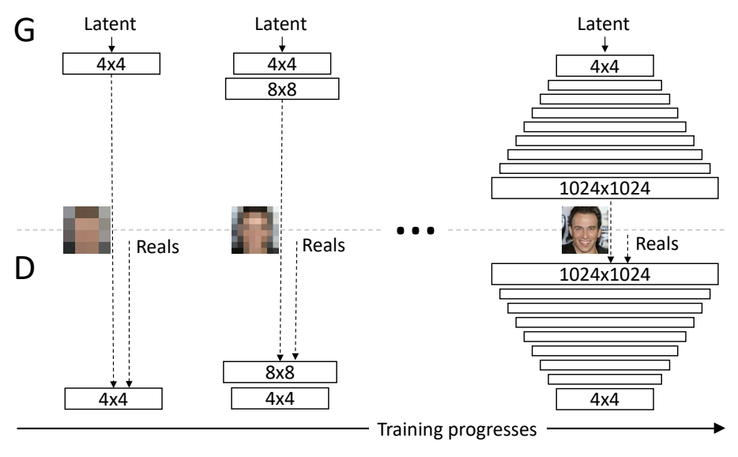

Example of the Progressive Growing of Generative Adversarial Networks During Training.  
Taken from: Progressive Growing of GANs for Improved Quality, Stability, and Variation.

### Big Generative Adversarial Network (BigGAN)

The big generative adversarial network, or BigGAN for short, is an approach that demonstrates how high-quality output images can be created by scaling up existing class-conditional GAN models.

*We demonstrate that GANs benefit dramatically from scaling, and train models with two to four times as many parameters and eight times the batch size compared to prior art.*

*—*[*Large Scale GAN Training for High Fidelity Natural Image Synthesis*](https://arxiv.org/abs/1809.11096)*, 2018.*

The model architecture is based on a collection of best practices across a wide range of GAN models and extensions. Further improvements are achieved through systematic experimentation.

A “*truncation trick*” is used where points are sampled from a truncated Gaussian latent space at generation time that is different from the untruncated distribution at training time.

*Remarkably, our best results come from using a different latent distribution for sampling than was used in training. Taking a model trained with z ∼ N (0, I) and sampling z from a truncated normal (where values which fall outside a range are resampled to fall inside that range) immediately provides a boost*

— [Large Scale GAN Training for High Fidelity Natural Image Synthesis](https://arxiv.org/abs/1809.11096), 2018.

### Style-Based Generative Adversarial Network (StyleGAN)

The style-based generative adversarial network, or StyleGAN for short, is an extension of the generator that allows the latent code to be used as input at different points of the model to control features of the generated image.

*… we re-design the generator architecture in a way that exposes novel ways to control the image synthesis process. Our generator starts from a learned constant input and adjusts the “style” of the image at each convolution layer based on the latent code, therefore directly controlling the strength of image features at different scales.*

— [A Style-Based Generator Architecture for Generative Adversarial Networks](https://arxiv.org/abs/1812.04948), 2018.

Instead of taking the point in the latent space as input, the point is fed through a deep embedding network before being provided as input at multiple points in a generator model. In addition, noise is also added along with the output from the embedding network.

*Traditionally the latent code is provided to the generator through an input layer […] We depart from this design by omitting the input layer altogether and starting from a learned constant instead. Given a latent code z in the input latent space Z, a non-linear mapping network f : Z -> W first produces w ∈ W.*

— [A Style-Based Generator Architecture for Generative Adversarial Networks](https://arxiv.org/abs/1812.04948), 2018.

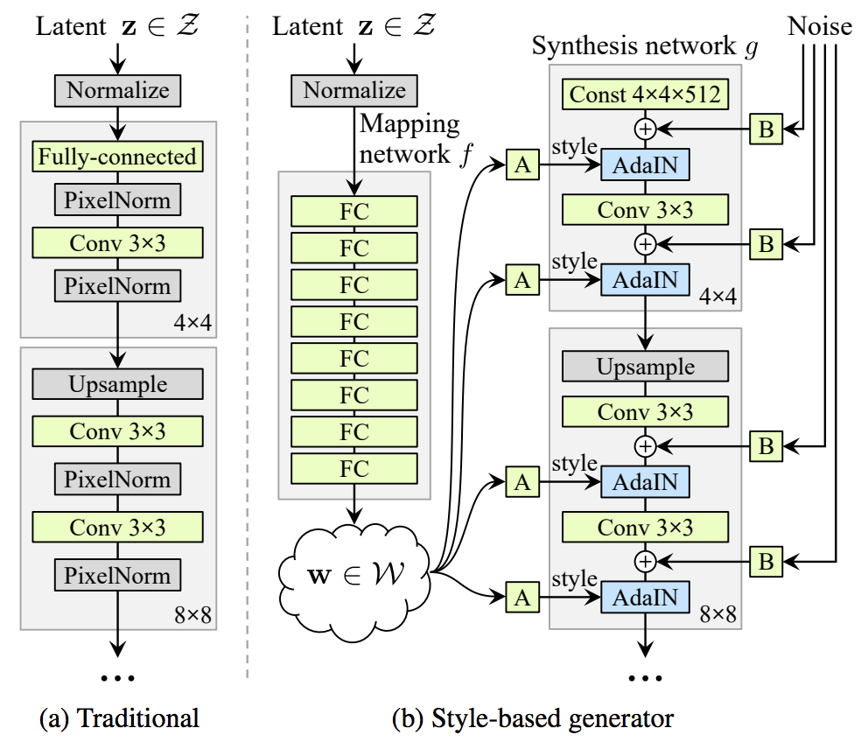

Example of the Traditional Generator Architecture Compared to the Style-Based Generator Model Architecture.  
Taken from: A Style-Based Generator Architecture for Generative Adversarial Networks.

**Image Processing Using Deep Learning**

Since the advent of digital camera technology, image processing (both on-device and postprocessing) has become a staple in most (if not all) photographers’ workflows. This ranges from simple on-device processing, such as increasing saturation and sharpness immediately after capture, to complex editing of raw image files in software applications like Adobe Photoshop and Lightroom. Machine learning has been used extensively in on-device processing, where the camera manufacturer would like the image that the consumer sees to be vibrant and pleasing to the eye with minimal user effort. Some examples of this are: Early face-recognition algorithms in point-and-shoot cameras, which optimize the exposure and focus for faces or even selectively fire the shutter when they recognize that the subject is smiling.

Scene-detection algorithms that adjust the exposure settings to capture the whiteness of snow or activate the flash for nighttime photos In the postprocessing arena a variety of automatic tools exists, although generally photographers who are taking the time to postprocess images are investing considerable time and domain-specific knowledge into color and exposure correction, denoising, sharpening, tone mapping, and touching up (to name just a few of the corrections that may be applied).

Historically, these corrections have been difficult to execute programmatically, because, for example, denoising might need to be applied selectively to different images and even different parts of the same image. This is exactly the kind of intelligent application that deep learning is poised to excel at. In a 2018 paper from Chen Chen and his collaborators at Intel Labs, deep learning was applied to the enhancement of images that were taken in *near total darkness*, with astonishing results. In a phrase, their deep learning model involves convolutional layers organized into the innovative U-Net architecture (which we break down for you in later Chapters).

The authors generated a custom dataset for training this model: the See-in-the-Dark dataset consists of 5,094 raw images of very dark scenes using a short-exposure image21 with a corresponding long-exposure image (using a tripod for stability)

A sample image (left) processed using a traditional pipeline (center) and the deep learning pipeline by Chen et al. (right)

Limitations aside, this work nevertheless provides a beguiling peek into how deep learning can adaptively correct images in photograph postprocessing pipelines with a level of sophistication not before seen from machines.

**Summary**

In this chapter we talked about AI, Creativity, Meaningful AI Art, Image Generation, Vector Spaces, Latent Spaces before introducing GANs. We discussed how this deep learning approach encodes exceptionally sophisticated representations within their latent spaces. These information rich compressed visual representations enable GANs to create novel images with particular, granular artistic styles. The outputs of GANs aren’t purely aesthetic; they can be practical, too. They can, as examples, simulate data for training autonomous vehicles, hurry the pace of prototyping in the fields of fashion and architecture, and substantially augment the capacities of creative humans and even pave the path to computational creativity.